DECLARATION

This is to certify that this project is an original work and was done by us and it has not been
submitted elsewhere for the requirement of any degree or diploma or for any other purposes except for publication.
OBEDI OBADIAH Mwendapeke
Signature…………………………………………….

MARIE WILONDJA Tchoke
Signature ……………………………………………

APPROVAL

This is project entitled “Bank Customers Management System” submitted by OBEDI OBADIAH Mwendapeke, And MARIE WILONDJA Tchoke
, to the Department of Computer Science, at KIGALI INDEPENDENT
UNIVERSITY, is accepted as satisfactory for partial fulfilled of the requirements for the
Bachelor degree in Computer Science.
DATE
……………..…………/…..………./………………
SIGNATURE
…………………………………………………….
SUPPERVISOR: Eng. NZAYISENGA HABARUGIRA Marcellin

Copyright Reserved by the author. The text is Copyright © 2020.
OBEDI OBADIAH Mwendapeke and MARIE WILONDJA Tchoke. All rights Reserved.
No part of this Dissertation may be reproduced or transmitted without prior written permission
of the author.

DEDICATION
We dedicate this research project to our :
- Parents;
- Brothers;
- Sisters;
- Relatives and to everyone who contributed to the success of our project financially, scientifically, and morally.

In memoriam

NYANYA MWENDAPEKE Amos

ACKNOWLEDGEMENT
First of all, we thank the almighty God, for giving us strength, knowledge to follow and do our work and for assisting us from the beginning till the end of our studies; to fill his grace upon us by giving us the health and knowledge to reach at the fulfillment of this great work.

We express our deepest gratitude to the president and founder of ULK (Kigali Independent University), Prof. Dr RWIGAMBA BALINDA for bearing us as his children, for his guidance, for his precious advices that has been providing us during our whole study as well as meaningful values that make us all what we are.

Foremost, we thank our Kigali independent university authorities, and especially our supervisor, the head of computer science department Eng. NZAYISENGA HABARUGIRA Marcellin, who despite the multitude of responsibilities and works he has, accepted to take of his time to provide us as well as all corrections, contributions for the fulfillment of this project work, guided us during the process of making our research project.

We thank whole of the department of computer science for their cooperation and important support. Being at the end of our scientific work, we are sincerely thankful to all other teaching stuff for their valuable teaching and constant advice which made me to finish this program successfully.

Our deepest gratitude goes to our parents who have given us much needed comfort, support, encouragement and inspiration for completing this project.
We cannot end our project without expressing our thinks to our class mate, special thanks to all those who have contributed directly and indirectly to the completion of this project.
We are so grateful to our family members, especially to our parents who have done all their efforts and everyone who helped us for the success of our work.

It could not be possible to finish this great without thanking our parents who guided us a lot in this tuff period of studies we have completed by providing us advices, school fees, food, wearing and so many things. We say thank you a lot.

LIST OF ABBREVIATIONS AND ACCRONYMS
DBMS : Database Management System
DFD : Data Flow Diagram
DLL : Dynamic Link Languages
ERD : Entity Relationship Diagram
IDE : Integrated Development Environment
NoSQL : not-only SQL
RAM : Random Access Memory
RDBMS : Relational Database Management System
RDSMS : Relational Data Stream Management Systems
ROM : Read Only Memory
SDLC : Software Development Life Cycle
SSADM : Structure Systems Analysis and Design Methodology
SQL : Structured Query Language

ABSTRACT

The main purpose of building and designing this project called “The Bank Customers Management Desktop Application” is to give Banks the ability to manage with efficiency their customers
The Design and development of this Bank customers Management system provides a more secured approach in managing bank customer’s information which strengthens the relationships between banks and their customers by providing the right solutions that uses a multi-level security to improve customer satisfaction.
In this paper we try to analyze the existing bank customers management system and propose the new one.

During our development we have used methodologies such as the data collection methodology and the software development methodology. The data collection methodology that we used during our project is the interview techniques because it helped us to organize a conversation in order to obtain important informations about personal opinions. We used the documentation technique because it helped us to get concerned informations from books in the library, websites, and courses. Finally we used the observation technique because it helped us as well to observe by selecting, listening, reading what the banks are doing when managing their customers and provide banks customers services.
We used the software development methodology called Software Development Life Cycle (SDLC) which helped us to develop and design best and high quality software in a good way.

The bank customers management systems are used for managing bank customers services such as the bank account creation that oblige customers to provide all necessary details like the personal and applicant details that will be stored automatically in the database.
This system is also used to manage and to print automatically all transactions slips such as the Deposit; Withdrawal, Loan and Repayment transactions. The administrator is also allowed to manage all customers details by editing, deleting and updating those stored customers informations.
This computerized bank customers management system is also able to communicate all information of provided services to customers using the messages communications.
In conclusion, as we know that technology is considered to be the key driver for these changes around us. Many activities are handled electronically due to the acceptance of information technology at home as well as at workplace that why we developed and design our project entitled Bank Customers Management System that has a purpose of facilitating banks to manage their customers without complications and make customers transactions efficiently.

Finally, we recommend to other researchers interested with this project to implement another version of this project and add other features such as the customer money transfer, the loan transactions of a group of people, the human resources management that will make this project more helpful.

TABLE OF CONTENTS

DECLARATION i
APPROVAL ii
DEDICATION iv
ACKNOWLEDGEMENT v
LIST OF ABBREVIATIONS AND ACCRONYMS vi
ABSTRACT vii
TABLE OF CONTENTS ix
TABLE OF FIGURES xi
CHAPTER 0. GENERAL INTRODUCTION 1
0.1 BACKGROUND 1
0.2 PROBLEM STATEMENT 2
0.2.1 Definition: 2
0.3 HYPOTHESIS 3
0.3.1 Definition 3
0.4 PROJECT OBJECTIVE 4
0.4.1 General Objective 4
0.4.2 Specific Objective 4
0.5 INTEREST OF THE SUBJECT 5
0.5.1 Personal Interest 5
0.5.2 Public Interest 5
0.6 SCOPE OF THE PROJECT 5
0.6.1 Scope in space 5
0.6.2 Scope in time 5
0.6.3 Scope in field (Domain) 5
0.7 ORGANISATION OF THE PROJECT 6
CHAPTER 1. LITERATURE REVIEW 7
1.1 INTRODUCTION 7
1.2 DEFINITION OF KEY TERMS 7
1.2.1 Design 7
1.2.2 Implementation 7
1.2.3 Bank 8
1.2.4 Bank Customers 8
1.2.5 Management 8
1.2.6 Report 9
1.2.7 Project 9
1.2.8 System 9
1.2.9 Software 9
1.2.10 Desktop application 9
1.2.11 User Interface 10
1.3 TOOLS AND LANGUAGES USED IN IMPLEMENTATION 10
1.3.1 C-sharp ( C# ) 10
1.3.2 Microsoft SQL Server 10
1.4.3 Visual Studio Community 11
1.4.4 Bunifu UI Frameworks 11
1.4.5 Cristal Report 11
1.5 DATABASE CONCEPTS 12
1.5.1 Information 12
1.5.2 Data 12
1.5.3 Database 12
1.5.4 Database security 12
1.5.5 Data Management System (DBMS) 12
1.5.6 Table 13
1.5.7 Records 13
1.5.8 Field 13
1.5.9 Query 13
1.5.10 Database server 13
1.6 DATA MODELING 13
1.6.1 Attributes 13
1.6.2 Foreign key 14
1.6.3 Database Relations 14
1.6.4 Entity 14
1.6.5 Cardinality 14
CHAPTER 2. PROJECT METHODOLOGY 15
2.1 INTRODUCTION 15
2.2 DATA COLLECTION METHODOLOGY 15
2.3 PROJECT SCHEDULE (GANTCHAT) 20
CHAPTER 3. SYSTEM ANALYSIS AND DESIGN 21
3.1 INTRODUCTION 21
3.2 ANALYSIS OF THE CURRENT SYSTEM 21
3.2.1 INTRODUCTION 21
3.2.2 PROBLEM OF THE CURRENT SYSTEM 21
3.3 ANALYSIS OF THE NEW SYSTEM 22
3.3.1 INTRODUCTION 22
3.3.2 METHODOLOGICAL APPROACH. 23
3.3.3 SYSTEM REQUIREMENTS. 24
3.3.4 DESIGN OF THE NEW SYSTEM 25
3.3.4.2 DATA DICTIONARY (DD) 31
CHAPTER 4. SYSTEM IMPLEMENTATION 35
4.1 INTRODUCTION 35
4.2 INTERFACES OF THE SYSTEM 35
CHAPTER 5. CONCLUSION AND RECOMMANDATION 52
1. CONCLUSION 52
2. RECOMMANDATION 52
REFERENCES 53

TABLE OF FIGURES

Figure 1 System Development Life Cycle (SDLC) 17
Figure 2 Waterfall model 19
Figure 3 Gantt Chart 20
Figure 4 Data Flow Diagram Symbols 26
Figure 5 Data Flow Diagram (Context Diagram ) Level 0 27
Figure 6 Data Flow Diagram (Context Diagram) Level 1 for Administrator in the Bank Customer Management System 28
Figure 7 Data Flow Diagram (Context Diagram) Level 1 for Customer in the Bank Customer Management System 29
Figure 8 Entity Relationship Diagram 30
Figure 9 DATA DICTIONARY (DD) 34
Figure 10 Login interface 35
Figure 11 Home Dashboard Interface069800 36
Figure 12 Account Creation for Personal customer details Interface 37
Figure 13 Account Creation for Applicant details Interface 38
Figure 14 Bank Account details Interface 39
Figure 15 Transaction menu interface 40
Figure 16 Deposit transaction interface 41
Figure 17 Withdrawal Transaction Interface 42
Figure 18 Loan Transaction Interface 43
Figure 19 Repayment Transaction Interface 44
Figure 20 The Account Management Interface 45
Figure 21 Personal Details Management Interface 46
Figure 22 Applicant Details Management Interface 47
Figure 23 Bank Account Management Interface 48
Figure 24 The Administrator Registration Interface 49
Figure 25 Communication Sender Interface 50
Figure 26 Communication viewer Interface 51

CHAPTER 0. GENERAL INTRODUCTION

BACKGROUND

As we know the technology is defined as the application of scientific knowledge for practical purposes, and is all about the use and knowledge of techniques and processes for producing goods and services especially in companies and industries.
So Nowadays, the technology is going to be very more important in much kind of aspects for any developing bank services in recent days.
The bank does not need to take for a long-standing dealing with the manual techniques to save information of customer which can lead to a very serious waste of time, so budding technologies have altered the banking industry from paper and conventional approach to digital approach.

Today, banks are looking beyond the transactions to the full opportunity on how to manage their customers. Accordingly, they are moving beyond managing clients as simple contacts to a whole new level of client relationship management, crafting a superior commercial client experience that gives the bank a competitive advantage and a more loyal, profitable and committed customers. The main intention behind the commencement of electronic banking services is to provide the customers with an alternative that is more responsive and with less expensive options.
Now the right time of solving all those problems that many banks are facing just because of the deficiency of the computerized technology.
As the major aim of the bank is to serve customers in good conditions banks are facing, the reason why we have been concentrated to design and to implement the project of customer management to make easier the way banks are working when managing customers and to store many services or activities and among those services we can identify some of them such as the transaction service, withdrawal service, deposits service, loan, reimbursement, to describe how the patient is going to fulfill the admission form, to send feedback to customers(clients), to store all customer informations in the database in order to manage(edit, delete,) informations.
Thus a Bank customer’s management system was introduced as an important component to increase the quality of managing customers and specially to resolve the long waiting times, respite and queue of customers.
At present most of the banking applications are yet to respond to the rapidly growing attacks on their customer private data. Issues suck fraud operating within a conventional environment. However current systems are still trying to cope with the existing institutional structure, which is really meant for usual banking system only and not managing their customer’s information more effectively.
Lack of adequate security measure is making it really challenging to successfully transform the bank customer’s management systems from where it is now to where it should be.

PROBLEM STATEMENT

Definition:

The problem statement can be defined as written description of the issue or set of issues that would be addressed by the concerned research work and it identifies the gap between the current(problem) state and the desire(goal) state of a process or product. (Kush, Max, June 2015. "The Statement Problem". Quality Progress. 48)
It main purpose is to identify and explain the problems.
During the conception of this project we will be concentrated on how to give the difference between the current technology and the future technology with the use of some techniques and methods, and we will provide how to solve the problem of managing customers and to send feedback differently to the current one.
Look at the current system we are facing some problems such as:

- The less of the customer’s private datas in the company
During the development of our project we realize that customer private informations are lost cause of the lack of the computerized system that we’ll save all concerned datas.
- The rapid problem of the transaction processes.
During the development of our project we realize that when doing the bank transactions the customers has to spend a lot of time waiting to be served.
- The lack communication between the bank and their customers
During the development of our project we realize that the bank is not in a good communications with customer who are not closer with the bank.

From the problems mentioned above, questions can be formulated in this way:
- How the bank customers management will help banks to satisfy their customers?
- How to design and develop the bank customers management system?
- How banks can communicate with their customers.

HYPOTHESIS

Definition

A hypothesis can be defined as an idea or explanation that you test through study and experimentation. A hypothesis is something more than a wild guess but less than a well-established theory. (Hilborn, Ray; Mangel, Marc ,1997; Richard Feynman, 1965 “The Character of Physical Law” p.156),
It can be define also as a proposed explanation for a phenomenon. For a hypothesis to be a scientific hypothesis, the scientific method requires that one can test it. Scientists generally base scientific hypotheses on previous observations that cannot satisfactorily be explained with the available scientific theories. Even though the words "hypothesis" and "theory" are often used synonymously, a scientific hypothesis is not the same as a scientific theory. A working hypothesis is a provisionally accepted hypothesis proposed for further research, in a process beginning with an educated guess or thought. (Hilborn, Ray; Mangel, Marc (1997). “The ecological detective: confronting models with data. Princeton University Press”. p. 24), ( In general we look for a new law by the following process. First we guess it. ...", —Richard Feynman, 1965 “The Character of Physical Law” p.156)
In order to manage customers the bank need to secure and to prevent the company from the lack of customer’s private datas.
The big target is to design and develop an application to satisfy customers as much possible, and will help to perform some transaction as deposit, withdrawal and loan, will prevent from the lack of important informations.
To be closer with customers the bank must a printed paper that maintains all information of the company.
For each step of the bank process, our software will be able to perform some tasks such as:
- Customer admission and Account creation;
- Edit and Delete customer informations;
- View customer informations;
- Perform transactions (Deposit, Withdrawal and Loan);
- Being in closer communication with customers using messages;
- Printing Transactions (Deposit, Withdrawal, Loan and Repayment) Slips.
The development of this software helps us and facilitates the speed and good performance of bank services.

PROJECT OBJECTIVE
Our project has two objectives that are General objectives and Specific objectives.

General Objective

The main objective of this project is to develop, to improve and to implement the good performance of managing customers in a bank and to have a big interaction between a bank and customers effectively and efficiency.

Specific Objective

There are many specific objectives but according to our project we have been concentrated on only some of them such as:
- Providing printed Reports
- The deposit Slips and Reports;
- The withdrawal Slips and Reports;
- The Loan Slips and Reports;
- The List of registered customers;
- All available communications.
- Record automatically Informations
- To Save customers private datas;
- To save all transactions(Deposits, Withdrawals and Loans) informations;
- All communications details.
- To create a database which will store all informations
- To store customers informations;
- To store all transaction process;
- To store all communications.
- To have efficiency communication with customers
- To share services informations with the customers;
- Account balance checking;
- Transactions process communications.
- To describe and print the customers list.
- To print all available customers in the system.

INTEREST OF THE SUBJECT

The interest of this subject is improve the way of work when talking about bank services specially when dealing with customers safety

Personal Interest
During the development of this software, it will help us to:
- To put to practice the knowledge that we got from the class and the reality on the working field;

Public Interest
At the end of this project, the banks will be able:
- To serve customers effectively and in a quick way;
- To have all prevention from the lack of data and all time spending by manual computation operations.

SCOPE OF THE PROJECT

Every scientific work must be delimited in three ways:
- The scope in space;
- The scope in time;
- The scope in domain.

Scope in space
Our research project work is located in the DRC Country, in the North-Kivu Province precisely in Goma Town, in the Township of Goma.

Scope in time

This project is built in 2020 with the purpose of solving the problem of customers management within IMARA Cooperative of Savings and Credits (Small Bank).

Scope in domain

Particularly this project is built with the purpose of solving the problem of managing customers in a bank.

ORGANISATION OF THE PROJECT
This project contains five chapters:
- Chapter 1: The General introduction: This chapter is concerned with problem statement, problem scope and project purpose;
- Chapter 2: Literature Review: This chapter deals with the theoretical concepts it means it provides a description, summary and evaluation of each source;
- Chapter 3: System analysis and design: In this chapter we analyze the current system, the new one then put in place the methodology to be used, tools and the system requirements;
- Chapter 4: System implementation: In this chapter we will proceed by showing exactly how the system will work, in other words, we will:
  - Show how the information system should be built (i.e. physical system design).
  - Ensure that the information system is operational and used.
  - Ensure that the information system meets quality standard (i.e. quality assurance).
- Chapter 5: Conclusion and recommendations: in this chapter we provide the general conclusion

CHAPTER 1. LITERATURE REVIEW

INTRODUCTION
The main purpose of this chapter is to help the reader to get a complete, concise and clear understanding, comprehensive and practical and explanation used in this project.
Our study will provide the good way to manage customers information technologically, a well understanding of bank customers basic services and more on customers perceptions regarding banking services.
This project aims to provide critical information for managing the bank customers more effectively and understanding customer needs, matching customer needs to the best offers services.
Rather, to encourage financial services providers in making informed choices in the challenges, opportunities, effective practices in providing a safe and secured customer management and the best satisfaction of the customer and for profit maximization to the bank.

DEFINITION OF KEY TERMS

Design

A design is a plan or specification for the construction of an object or system or for the implementation of an activity or process, or the result of that plan or specification in the form of a prototype, product or process.
The verb to design expresses the process of developing a design. In some cases, the direct construction of an object without an explicit prior plan (such as in craftwork, some engineering, coding, and graphic design) may also be considered to be a design activity. The design usually has to satisfy certain goals and constraints, may take into account aesthetic, functional, economic, or socio-political considerations, and is expected to interact with a certain environment. Major examples of designs include architectural blueprints, engineering drawings, business processes, circuit diagrams, and sewing patterns. (Dictionary meanings in the Cambridge Dictionary of American English, at Dictionary.com , esp. meanings 1–5 and 7–8 and at AskOxford)

Implementation

In computer science, an implementation is a realization of a technical specification or algorithm as a program, software component, or other computer system through computer programming and deployment. Many implementations may exist for a given specification or standard. For example, web browsers contain implementations of World Wide Web Consortium-recommended specifications, and software development tools contain implementations of programming languages.
A special case occurs in object-oriented programming, when a concrete class implements an interface, in this case the concrete class is an implementation of the interface and it includes methods which are implementations of those methods specified by the interface.

Bank
A bank is a financial institution that accepts deposits from the public and creates a demand deposit while simultaneously making loans. Lending activities can be performed either directly or indirectly through capital markets.
Due to the importance of banks in the financial stability of a country, most jurisdictions exercise a high degree of regulation over banks.

Bank Customers

In sales, commerce and economics, a customer (sometimes known as a client, buyer, or purchaser) is the recipient of a good, service, product or an idea - obtained from a seller, vendor, or supplier via a financial transaction or exchange for money or some other valuable consideration.
Therefore, bank customers are people from the public which is a financial institution that accepts deposits from the public and creates a demand deposit while simultaneously making loans.

Management

Management (or Managing) is the administration of an organization, whether it is a business, a not-for-profit organization, or government body. Management includes the activities of setting the strategy of an organization and coordinating the efforts of its employees (or of volunteers) to accomplish its objectives through the application of available resources, such as financial, natural, technological, and human resources.
The term "Management" may also refer to those people who manage an organization called Managers.
Social scientists study management as an academic discipline, investigating areas such as social organization and organizational leadership. (Waring, S.P., 2016. Taylorism transformed: Scientific management theory since 1945. UNC Press Book.)

Report

A report is a document that presents information in an organized format for a specific audience and purpose. Although summaries of reports may be delivered orally, complete reports are almost always in the form of written documents. (Madan, Poonam (2016–2017). Language proficiency in English. 28/115, jyoti block, sanjay place, Agra-2: Agarwal publication. p. 138)

Project
In project management a project consists of a temporary endeavor undertaken to create a unique product, service or result. Another definition is: a management environment that is created for the purpose of delivering one or more business products according to a specified business case. Projects can also be seen as temporary organization. (R. Max Wideman (2004), A Management Framework: For Project, Program and Portfolio Integration. p. 30), (Turner, J. Rodney, and Ralf Müller. "On the nature of the project as a temporary organization." International journal of project management 21.1 (2003): 1-8)

System

A system is a group of interacting or interrelated entities that form a unified whole. A system, surrounded and influenced by its environment, is described by its boundaries, structure and purpose and expressed in its functioning. Systems are the subjects of study of systems theory. ("Definition of system". Merriam-Webster. Springfield, MA, USA. Retrieved 2019-01-16)

Software

Computer Software means computer instructions or data. Anything that can be stored electronically is software, in contrast to storage devices and display devices which are called hardware. (Vangie Beal, 2012, “Software Definition & Meaning”, webopedia.com)

In computer science and software engineering, computer software is all information processed by computer systems, programs and data.
Computer software includes computer programs, libraries and related non-executable data, such as online documentation or digital media. Computer hardware and software require each other and neither can be realistically used on its own. (The new social Operating System 2012, Wikipedia.com).

Desktop application

Desktop application is any program that can run and be installed and used to perform specific tasks on a single device. Some desktop programs in a networked environment cans also be used by multiple users.
A desktop application is one that runs in the standard windows browser, as opposed to a full-screen tablet application.
Desktop programs are mounted on a desktop computer for personal use or work. (Paul Monk, September 8,”Desktop Application meaning”, 2014)

User Interface

The User Interface (UI) of a computer program is the part
that handles the output to the display and the input from the person using the program. The goal of effective UI is make the user’s experience easy and intuitive, requiring minimum effort on the user’s part to receive maximum desired outcome. (Myers, B.A., 1995. User interface software tools. ACM Transactions on Computer-Human Interaction (TOCHI), 2(1), pp.64-103)

TOOLS AND LANGUAGES USED IN IMPLEMENTATION

C-sharp ( C# )

C# (pronounced "C-sharp") is a general-purpose, multi-paradigm programming language encompassing static typing, strong typing, lexically scoped, imperative, declarative, functional, generic, object-oriented (class-based), and component-oriented programming disciplines. (C# Language Specification (PDF) (4th ed.). Ecma International. June 2006. Retrieved January 26, 2012)

C# was developed around 2000 by Microsoft as part of its .NET initiative and later approved as an international standard by Ecma (ECMA-334) in 2002 and ISO (ISO/IEC 23270) in 2003. It was designed by Anders Hejlsberg, and its development team is currently led by Mads Torgersen, being one of the programming languages designed for the Common Language Infrastructure (CLI). The most recent version is 9.0, which was released in 2020 in .NET 5.0 and included in Visual Studio 2019 version 16.8. (Visual Studio 2019 Preview Release Notes". docs.microsoft.com), ("Download .NET 5.0:Linux, macOS, and Windows". Microsoft. Retrieved October 15, 2020)

Microsoft SQL Server

Microsoft SQL Server is a relational database management system developed by Microsoft. As a database server, it is a software product with the primary function of storing and retrieving data as requested by other software applications—which may run either on the same computer or on another computer across a network (including the Internet). Microsoft markets at least a dozen different editions of Microsoft SQL Server, aimed at different audiences and for workloads ranging from small single-machine applications to large Internet-facing applications with many concurrent users.
The history of Microsoft SQL Server begins with the first Microsoft SQL Server product—SQL Server 1.0, a 16-bit server for the OS/2 operating system in 1989—and extends to the current day. ("Editions and supported features of SQL Server 2019 (15.x)", microsoft.com)
SQL comprises of 3 major sub-languages:
      - Data Definition Language (DDL): to create and modify the structure of the database;
      - Data Manipulation Language (DML): to perform Read, Insert, Update and Delete operations on the data of the database;
- Data Control Language (DCL): to control the access of the data stored in the database. (SQL Notes for Professionals.pdf P2, www.GoalKicker.com).

Visual Studio Community

Microsoft Visual Studio community is an Integrated Development Environment (IDE) form Microsoft.
It is used to develop computer programs, as well as websites, web apps, web services and mobile apps. Visual Studio uses Microsoft software development platforms such as Windows API, Windows Forms, Windows Presentation Foundation, Windows Store and Windows SilverLight.
It can produce both native code and managed code.
The history of Microsoft Visual Studio begins with the first product which was Visual Studio 97, launched 19th March 1997.
This package can be considered as a learning IDE for students, hobbyists and newcomers to Visual Studio programming. (Microsoft Community, November 2020 “Visual Studio 2019 Release Notes". docs.microsoft.com.)

Bunifu UI Frameworks

Bunifu UI controls are driven tools to help you to build awesome desktop application interface. It guarantees great user experience in apps and reduces development time for Microsoft Visual Studio .NET software.
We currently target C# languages and the product is offered as DLL imported into the Visual Studio environment.
The DLLs are installed in the .NET environment and is built on top of the Win Forms. It enables developers to drag and drop hence faster coding.
It empowers developers to:
- Improve productivity
- Built modern stunning designs.
- (Microsoft.docs “Bunifu Framework - Visual Studio .NET UI tools” Bunifu Technologies, LTD, Microsoft.com)

Cristal Report

Cristal Report is a popular Windows based report writer solution that allows a developer to create reports and dashboards from a variety of data sources with a minimum of code to writer.
Cristal Report is owned and developed by SAP.
It is designed to produce reports from virtually any data source. Formulas, cross-tabs, sub-reports and conditional formatting help make sense of data and uncover important relationships that might otherwise be hidden. Data visualization tools such as geographic maps and graph communicate information visually to help in understanding data analysis and it can also publish in a variety of format including Microsoft Word and Excel, e-mail and over the web.

DATABASE CONCEPTS

Information

Information is associated with data, as data represent values attributed to parameters, and information is data in context and with meaning attached. Information also relates to knowledge, as knowledge signifies understanding of an abstract or concrete concept. ("Information - Definition of Information by Merriam-Webster". Merriam-webster.com)

Data

Data can be defined as information, especially facts or numbers, collected to be examined and considered and used to help with making decisions. Or information in an electronic form that can be stored and used by computer. (“Definition of Data” by merriam-webster.com, 1646)

Database

Database is an organized collection of data, generally stored and accessed electronically from a computer system. Where database are more complex they are often developed using formal design and modeling techniques. (Ullman, Jeffrey, Widom, Jennifer (1997). A First Course in Database Systems)

Database security

Database security refers to the range of tools, controls and measures designed to establish and preserve database confidentially since it’s the element that’s compromised in the most breaches.
Database security is a complex and challenging endeavor that involves all aspects of information security technologies and practices. (IBM Cloud Education. August27, 2019 Wikipedia.com)

Data Management System (DBMS)

Data Management System (DBMS) is software designed to store, retrieve, define and manage data in a database.
DBMS software primarily functions as an interface between the end user and the database, simultaneously managing the data. The database engine and database schema in order to facilitate the organization and manipulation of data.
A database management system functions through the use of system commands, first receiving instructions from database administrator in DBMS, then instruction the system accordingly, either to retrieve data, modify data, or load existing data from the system.

Table

A table is a collection of related data held in a table format within a database; it consists of columns and rows.
In relational databases, and flat file databases, a table is a set of data elements (values) using a model of vertical columns (identifiable by name) and horizontal rows, the cell being the unit where a row and column intersect. (Merriam-Webster, "table definition”, May 29, 2012.)

Records

A record is a database entry that may contain one more values. Group of records are stored in a table, which defines what types of data each record may contain. Database may contain multiple tables which may each contain multiple records. (Techterms.com. August 25, 2012)

Field

A database field is a single piece of information from a record. A database record is a set of fields.

Query

A query is a way of requesting information from the database. A database query can be either a select query or an action query.
A select query is a query for retrieving data, while an action query requests additional action to be performed on the data, like deletion, insertion and updating.

Database server

Database server is a server which uses a database application that provides database services to other computer programs or to computers, as defined by client-server model. (Thakur Dinesh. February 03, 2018).

DATA MODELING

Attributes

Attributes is refers to a database component, such as table. It also may refers to a database field.
Attributes describe the instance in the column of a database.

Foreign key

A foreign key is a field (or collection of fields) in one table that refers to the primary key in another table.
The table containing the foreign key is called the child table, and the table containing the candidate key is called the referenced or parent table.

Database Relations

Database relation is sometimes used to refer to a table in a relational database but is more commonly used to describe the relationship that can be created between those tables in a relational database. (Chen Peter, March 1976)

Entity

An entity is an on object that exists. It doesn’t have to do anything; it just has to exit. In database administrator. Entity can be a single thing, person, place, or subject. Data can be stored about such entities. A design tool that allows database administrator to view the relationship between several entities is called the entity relationship diagram (ERD). (Martin Gibb, “The Entity relation defintion”, 2016)

Cardinality

The cardinality is all about how may distinct values are in the column, when applied to databases, the meaning is a bit different: it’s the number of distinct values in a table column, relative to the number of rows in the table.

CHAPTER 2. METHODOLOGY

INTRODUCTION

This chapter covers the methods, techniques and approaches used during our project development in order to obtain concerned datas and informations from field.
A methodology is known as a system of practices, techniques, procedures, and rules used by those who work in a discipline. (Dinnie Muslihat, March 9, 2018 » Popular Project Management Methodologies»)
They are essentially processes that aim to assist project managers with guidance throughout the project, and the steps to take to completing the tasks. Different methodologies have different strategies that aid in managing issues should they arise during the project’s delivery.
To complete such scientific work is not hazardous. It’s the result from the research methodology and the chosen techniques.

DATA COLLECTION METHOLOGIES

The data collection methodology can be define as the process of gathering and measuring information on targeted variables in an established system, which then enables one to answer relevant questions and evaluate outcomes. Data collection is a component of research in all fields of study including physical and social sciences, humanities, and business. (Lescroël, A. L. ; Ballard, G.; Grémillet, D.; Authier, M.; Ainley, D. G. (2014). Descamps, Sébastien (ed.). "Antarctic Climate Change: Extreme Events Disrupt Plastic Phenotypic Response in Adélie Penguins").
In order to collect data, we have used interview, observation and documentation techniques.

- Techniques of interview
The interview technique consists to organize a conversation in which the investigator asks questions to the surveyed person in order to elicit information.
Interviews are a part of the hiring process as it gives an in-depth impression of the applicant to the interviewer. It is vital to get the most out of an interview with the help of suitable questions and active listening to gauge the mood and behavioral pattern of the candidate.
Interviewing is a popular way of gathering qualitative research data because it is perceived as "talking," and talking is natural. This column discusses the type of interview most often used in educational evaluation: the semistructured interview. A semistructured interview means questions are predetermined, but the interviewer is free to ask for clarification. During an interview evaluation, the following issues and decisions need to be addressed: Decide whom to interview, choose when to stop a particular interview, Select a place for the interview, Decide which questions to ask, and Consider how the data will be collected. (Griffee, D.T., 2005. Research Tips: Interview Data Collection. Journal of Developmental Education, 28(3), pp.36-37)
Different scholars have defined ‘interview’ differently. According to Scott and others, “an interview is a purposeful exchange of ideas, the answering of questions and communication between two or more persons”. Bingham and others define an interview as a ‘conversation with a purpose”.
Objectives of Interview:
In the selection process, interview serves the following objectives:
- Verifies the information obtained through application form and tests.
- Help obtain additional information from the applicant otherwise not available.
- Gives the candidate necessary fact and information about the job and the organization.
- Helps establish mutual understanding between the company and the candidate and build the company’s images.
As this technique is based on the communication between the interviewer and the interviewee, we have used it to allow us to ask many questions regarding to our study to different customers and the bank director.

- Technique of documentation
In order to conduct our research, documentation technique has been used for consulting a wide variety of documents such as different books in the library, website to read some online courses.

- Techniques of observation
Bas du formulaire
Observation is a technique that involves systematically selecting, watching, listening, reading, touching, and recording behavior and characteristics of living beings, objects, or phenomena.
The researchers, adopting this method, attempt to understand behavior and societies by getting to know the persons involved and their values, rituals, symbols, beliefs, and emotions.
Use of observation as a measurement procedure, assigning numerals to human behavioral acts, is discussed.
Observation has important advantages which makes it best suited for certain kinds of studies, and some limitations which preclude its use in others. The central problems in the use of observation are:
- He effect of the observer on the observed, which is usually not severe and can be minimized;
- Observer inference, which is a crucial strength and a crucial weakness;
- The unit of behavior to be used, which involves the molar-molecular problem.
The considerations in planning both unstructured and structured observation studies are discussed, including what to observe, how to record it, how to maximize validity and reliability, and how to handle the relationship between the observer and the observed. Behavior is usually sampled using event sampling or time sampling. (Barker, K.N., 1980. Data collection techniques: observation. American Journal of Hospital Pharmacy, 37(9), pp.1235-1245)
The technique qualifies as a scientific method of data collection when it is specially designed to answer a research question and is systematically planned and executed with proper controls.
- Software development methodology
In this step, we are going to use a SDLC which is the process used by the software industry to design, develop and test high quality software. The SDLC aims to produce high quality software that meets or exceeds customer expectations, reaches completion within times and cost estimates.

The following figure is a graphical representation of the various stages of a typical SDLC
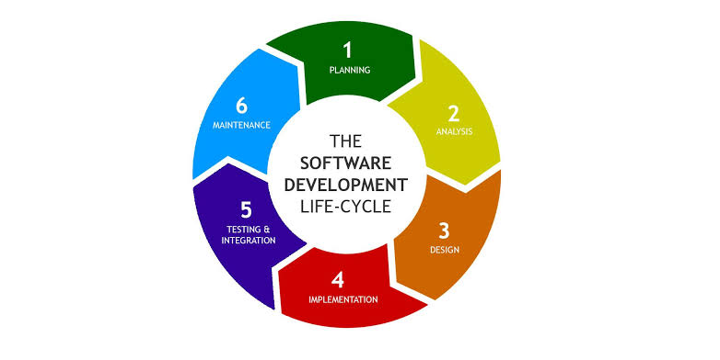
Figure 1 System Development Life Cycle (SDLC)
Source: From medium.com

Stage 1: Planning and Requirement Analysis
Requirement analysis is the most important and fundamental stage in SDLC it’s performed by the senior members of the team with inputs from the customer, the sales department, market surveys and domain experts in the industry. The planning for the quality assurance requirements and identification of the risks associated with the project is also done in the planning stage.

Stage 2: Defining Requirements
Once the requirement analysis is done the next step is to clearly define and document the product requirements and get them approved from the customer or the market analysis. This is done through an SRS (Software Requirement Specification) document which consists of all the product requirements to be designed and developed during the project life cycle.
Stage 3: Designing the product Architecture
SRC is the reference for product architects to come out with the best architecture for the product to be developed.
Stage 4: Building or developing the product
In this stage of SDLC the actual development starts and the product is built. The developers must follow the coding guidelines defined by their organization and programming tools like compilers, interpreters, debuggers, etc. are used to generate the code.
Stage 5: Testing the product
This stage is usually a subset of all the stages as in the modern SDLC models, the testing activities are mostly involved in all the stages of SDLC.
Stage 6: Deployment in the Market and Maintenance
Once the product is tested and ready to be deployed it is released formally in the appropriate market.

CHOICE OF THE SDLC MODELS

There are various software development life cycle models defined and designed which are followed during the software development process but among them we have chosen to use the waterfall model for this project.

1.5.3 Waterfall model
Waterfall approach was the first SDLC model to be used widely in software engineering to ensure success of the project. In this model approach, the whole process of software development is decided into separate phases and the outcome of one phase acts as the input for the next phase sequentially.

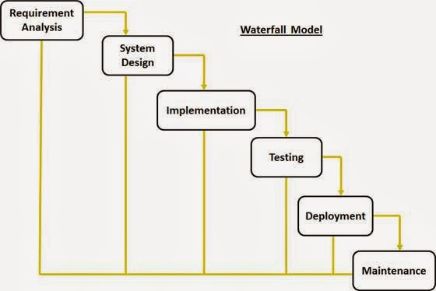
Figure 2 Waterfall model
Source: From Tutorialspoint.com
The sequential phases in Waterfall model are:
- Requirement Gathering and analysis: All possible requirements of the system to be developed are captured in this phase and documented in a requirement specification document;
- System Design: The requirement specifications from first phase are studied in this phase
and the system design is prepared. This system design helps in specifying hardware and
system requirements and helps in defining the overall system architecture;
- Implementation: With inputs from the system design, the system is first developed in
small programs called units, which are integrated in the next phase. Each unit is developed and tested for its functionality, which is referred to as Unit Testing;
- Integration and Testing: All the units developed in the implementation phase are integrated into a system after testing of each unit. Post integration the entire system is tested for any faults and failures;
- Deployment of system: Once the functional and non-functional testing is done; the
product is deployed in the customer environment or released into the market;
- Maintenance: There are some issues which come up in the client environment. To fix those issues, patches are released. Also, to enhance the product some better versions are released. Maintenance is done to deliver these changes in the customer environment.

Waterfall model advantages
- Simple and easy to understand and use;
- Easy to manage due to the rigidity of the model. Each phase has specific deliverables and a review process;
- Phases are processed and completed one at a time;
- Works well for smaller projects where requirements are very well understood;
- Clearly defined stages;
- Well understood milestones;
- Easy to arrange tasks;
- Process and results are well documented.

PROJECT SCHEDULE (GANTCHAT)

N0 | Task | Start | End | Year 2020
 |  |  |  | Jan | Feb | Mar | April | May | Jun | July | Aug | Sept | Oct
01 | System feasibility | 10/January | 30/Jan
02 | Requirements analysis and project planning | 1/January | 10/Feb
03 | System design | 12/February | 20/Apr
04 | System development | 22/April | 30/Aug
05 | System Test | 1/September | 30/Sept
06 | System Implementation | 2/October | 20/Oct

Figure 3 Gantt Chart
Source: Own drawing

CHAPTER 3. SYSTEM ANALYSIS AND DESIGN

INTRODUCTION
In this chapter, the main objective is not only the design and structure of the bank customers management but also to analyze and describe deeply and concisely how the current project works. This chapter will cover and present also the problems caused by the current project and finally mentioned the proposed system working principle will be compared.
Firstly, before making any comment to the existing system, we first have to examine the current system so that may we identify problems and functionalities in order to facilitate us to develop the future system and to retrieve some errors in it to be corrected in the future system that provides acceptable and useful solutions concerning the bank customers management.

ANALYSIS OF THE CURRENT SYSTEM

INTRODUCTION

According our examination and analysis we got some errors in current system that must be solved in the future system and we’ve been able to propose some solutions that will be described in this phase.
After analyzing the existing bank customers management we realize that the registration reports was done manually because the system is not computerize. The current system took a lot of time to provide to the customer the deposit, the withdrawal, the loan and the repayment slips.
These are factors that cause the delay of the bank customer services because the current system doesn’t provide communications with customer.
As customers of all bank are interested in banking services that provides a better customers management approach, but at the same they are facing problems like spending time while saving the Deposit, Withdrawal, Loan and Repayment slips which are done manually.

PROBLEM OF THE CURRENT SYSTEM
The following problems are problems identified in the current system after examination:
- The lack of the customer’s private datas in the company.
- The speed problem of the transaction processes.
- Issues suck fraud operating within a conventional environment.
- Lack of adequate security measure is making it really challenging to successfully transform the bank customers;
- The lack communication between the bank and their customers;
- The current system spend a lot of times to provide Deposit, Withdrawal, Loan and Repayment Slip;
- There is no database for storing transaction Deposit, Withdrawal, Loan and Repayment Slip details.

ANALYSIS OF THE NEW SYSTEM

INTRODUCTION

In order to overcome the limitation and problems of the current system, this dissertation proposed to develop a computerized application named” Bank customers bank management”. In the following, we are going to provide the current system and to describe how important will be differently to the current one.
The proposed system is computerized as the technology is advanced, to register customers the system save data in the database by inserting the personal details and applicants details and the bank account details.
To manage customers data the system provide de client details management in order to update and delete customers private informations. Therefore the customer will be able to make transactions (Deposit, Withdrawal, Loan and Repayment).
The future system is computerized as the technology is growing up and getting advanced very fast, everything needs to be updated in order to satisfy the needs of customers. That why we are going to design the proposed system which will solve all previous system problems such as to print Deposit, Withdrawal, Loan and Repayment slips faster than the previous.
Therefore the system will provide the customers all information in order to inform all possible bank movement, and system will be very helpful features and new services that are not in the current system.

METHODOLOGICAL APPROACH.
Methodology is a formal development process that defines a set of activities, methods, practices, deliverables and automated tools that are used by developers and projects managers to implement and maintain information systems.

Data collection techniques
To understand deeply the requirement and the problem domain, some techniques will help to achieve the aim of this dissertation. The three main techniques used are “Documentation”, “Interview” and “Observation”.

- Documentation technique
This technique allows the researcher to consult books, memories, class notes and search some documents on internet that are related to his work.
- Interview
In this research the interview technique has been used as data collection technique, it consisted of the conversation between the researcher and the person holding some key information.
- Observation
Observation is a systematic data collection approach. Researchers use all of their senses to examine people in natural settings or naturally occurring situations.

Software Development Process Model

The development models are the various processes or methodologies that are being selected for the development of the project depending on the project’s name objectives. Many development life cycle have been developed to allow people to reach different objectives. In this dissertation, the waterfall model has been preferred.

SYSTEM REQUIREMENTS.

The system requirement has two parts, functional requirement and non-functional requirement. The functional requirement is composed by what the system is intended to do while the non-functional requirement define how the system is supposed be.

Functional requirements

A functional requirement defines the basic system behavior. Essentially, they are what the system does or must not do, and can be thought of in terms of how the system responds to inputs. Functional requirements usually define if/then behaviors and include calculations, data input and business process.
Functional requirement are features that allow the system to function as it was intended. Put another way, if the functional requirements are not met, the system will not work. Functional requirement are product features and focus on use requirement.
The following are functional requirement of the future system:
- System Administrator
- The administrator will:
- Register customer personal details, applicant details and bank account details;
- Manage (View, Update, Delete) all customers details;
- View all available customers in the system;
- Make the customer transaction such as Deposit, Withdrawal, Loan and Repayment;
- Manage account details and check the customer account solde;
- Provide all possible Deposit, Withdrawal, Loan and Repayment slips;
- Provide all services report.
- Customers (Clients)
- The customer will:
- Provide Personal details, Applicant details;
- Data management request;
- Transactions request.

Non-functional requirements

Non-functional requirements specify how the system should do. Non-functional requirement don’t affect the basic functionality of the system (hence the name, non-functional requirements). Even if the non-functional requirements are not met, the system will still perform it basic purpose.
Non-functional requirement descriptions:
- The system shall be always available and accessed during working time.
- The system should work without any interruption; data should arrive on time respecting their integrity in order to allow the system and the administrator to take good decisions.
- The system speed and accuracy processing accuracy should be high so that the customers requests will be handled rapidly.
- The system should be easy to adapt and integrate in any bank customers services.
- The system should be available at any time and in any kind of environment except when working conditions are not respected.

If a system will still perform without meeting the non-functional requirements, why are they important? The answer is usability. Non-functional requirements define system behavior, features, and general characteristics that affect the user experience. How well non-functional requirements are defined and executed determines how easy the system is to use, and is used to judge system performance. Non-functional requirements are product properties and focus on user expectations.

DESIGN OF THE NEW SYSTEM

In order to design the future system, we deal with the function diagram, context-diagram, Data Flow Diagram level 0, Level 1 and Level 2 and Entity Relationship Diagram. Here the structures of the described diagrams.

FUNCTION DIAGRAM

A function diagram in software engineering is a block diagram that describes the functions (Activities, Actions, Processes and Operations) and interrelations of a system.

DATAFLOW DIAGRAM

Data Flow Diagram is one the tools used in Software design representing a system at any level of detail with a graphic network showing Data flows, Data store, Data process and Data sources/destination.

- Purpose and Objective of the Dataflow Diagram

The purpose of data flow diagrams is to provide a semantic bridge between users and systems developers.
The goal of data flow diagramming is to have a commonly understood model of a system. The diagrams are the basis of structured systems analysis. Data flow diagrams are supported by other techniques of structured systems analysis such as data structure diagrams, data dictionaries.

- Dataflow Diagram Symbols
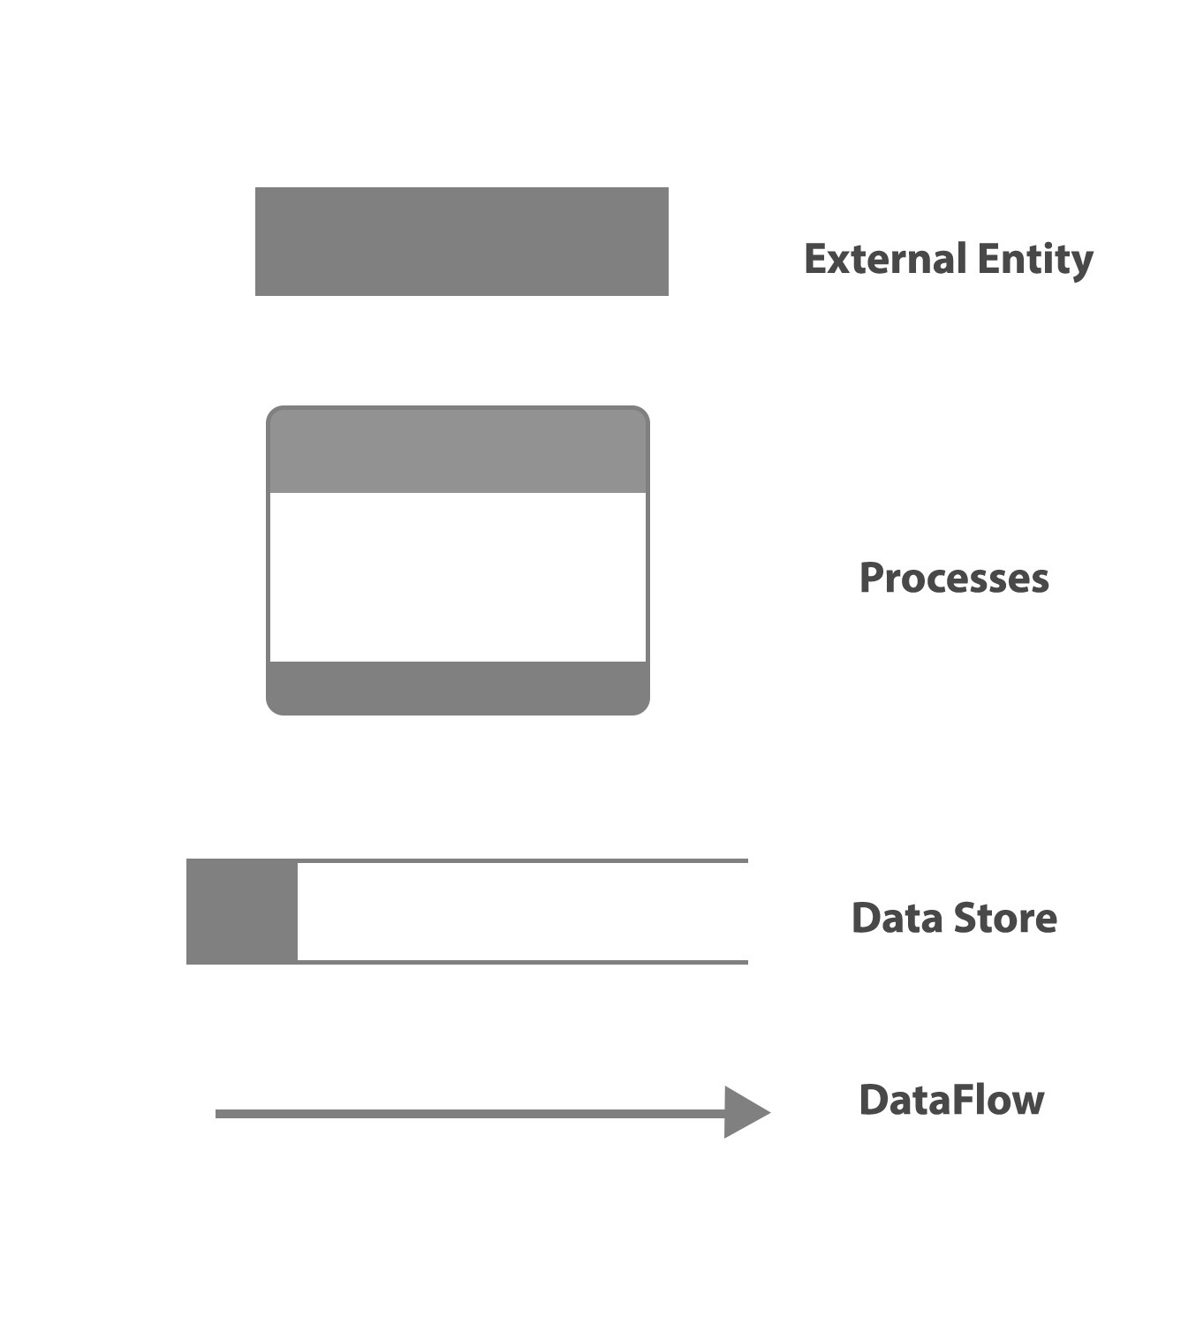

Figure 4 Data Flow Diagram Symbols
Source: Own drawing
The DFD has basically 4 components which are:

- The External Entity: represents sources of data to the system or destinations of data from the system. They are objects outside the system, with which the system communicates. External entities are sources and destinations of the system's inputs and outputs.
- The Data Flow: symbol represents movement of data. They are pipelines through which packets of information flow. Label the arrows with the name of the data that moves through it.
- The Data Store: symbol represents data that is not moving (delayed data at rest). They are repositories of data in the system. They are sometimes also referred to as files.
- The Process: symbol represents an activity that transforms or manipulates the data (combines, reorders, converts, etc.). It transforms incoming data flow into outgoing data flow.
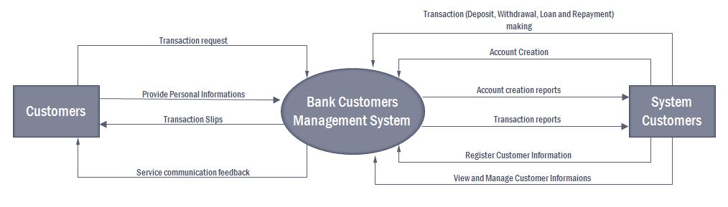
Figure 5 Data Flow Diagram (Context Diagram ) Level 0
Source: Own drawing
In the figure above, the customer will firstly provide all necessary informations for the account creation then the system administrator will register customers information in the system, he or she will make the transactions (Deposit, Withdrawal, Loan and Repayment), the administrator can also view and manage (Update and Delete) customer informations. After that the system will deliver to the customers transactions slips and send to the customer services communication. The system will provide to the administrator the account creation and transactions printed reports.
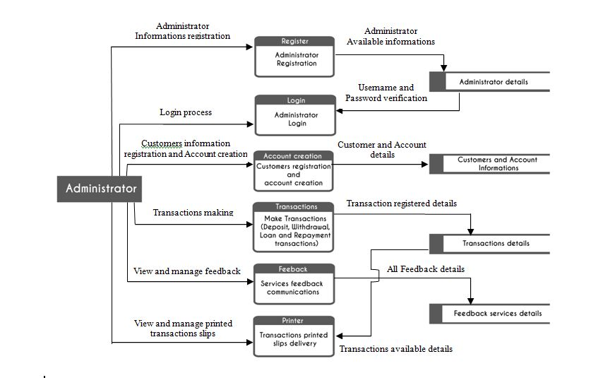
Figure 6 Data Flow Diagram (Context Diagram) Level 1 for Administrator in the Bank Customer Management System
Source: Own drawing
In this figure the system allow the administrator to register his personal details so that he may login the system, after login the system has to verify if the entered username and password are correct. The administrator registers the customer informations and creates the customer bank account which will be stored in the data store; the administrator can also make the customer transactions and store all transactions details, the system allows the administrator the manage and view the printed transactions slips, view and manage the feedbacks stored in the database.

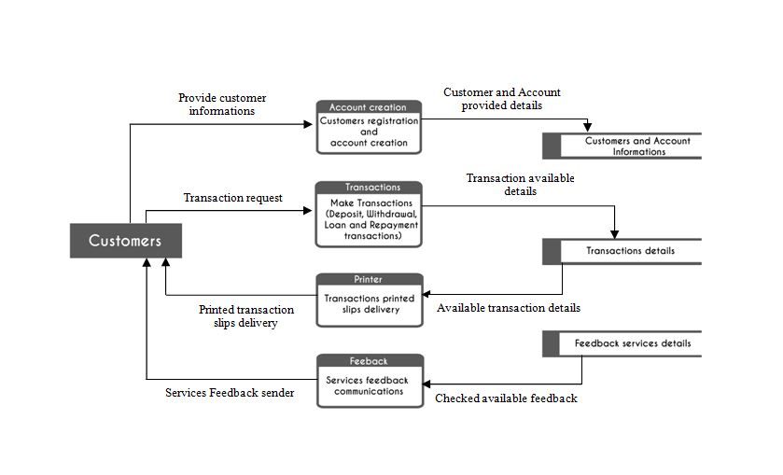
Figure 7 Data Flow Diagram (Context Diagram) Level 1 for Customer in the Bank Customer Management System
Source: Own drawing
In this system above, the customer provide personal, Applicant and the Account details which will be stored in the data store, the customer provide also the transaction requests stored in the data store.
The above system illustrate how the system will deliver to the customer the printed transactions (Deposit, Withdrawal, Loan and Repayment) slips; and how the customer will receive services feedbacks communications.

ENTITY RELATIONSHIP DIAGRAM

An Entity Relationship Diagram (ERD) is a visual representation of different entities within a system and how they relate to each other; they are widely used to design relational databases. The entities in the ER schema become tables, attributes and converted the database schema. Since they can be used to visualize database tables and their relationships it’s commonly used for database troubleshooting as well. (http://creately.com).

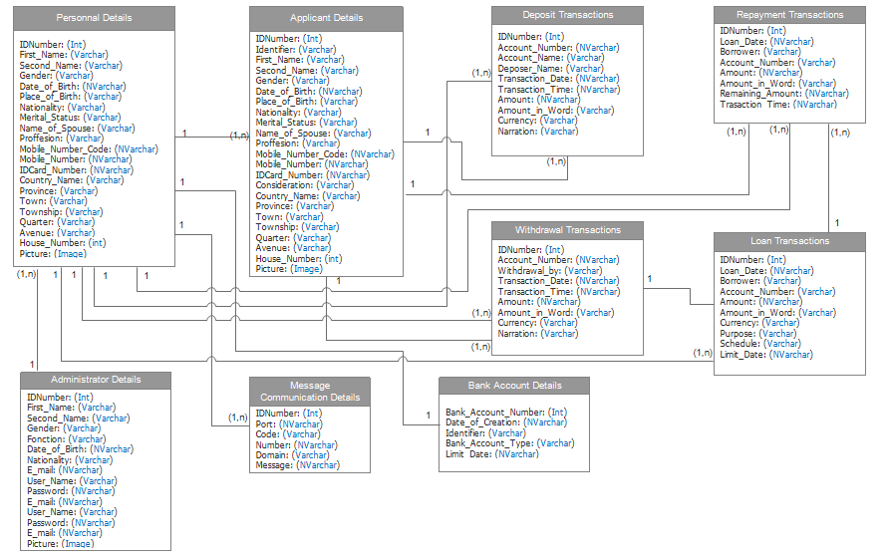
Figure 8 Entity Relationship Diagram
Source: From EdrawMax

In the Entity Relationship Diagram above, we realize that the system has basics entities such as Personal Details entity, Applicant Details entity, Bank Account Details entity, Deposit Transaction, Withdrawal Transaction, Loan Transaction, Repayment Transaction, Administrator Details, Message Communications Details.
The system improve that all entities are related each other through a relationship, one customer Personal details can have one or many Applicant Details and each Customer Personal Details must have one Bank Account Details.
All Personals and Applicants are allowed to make one or many Deposit, Withdrawal, Loan and Repayment Transactions.
The administrator can manage one or many customer personal details.
Each customer or one customer can receive one or many Message communications.

DATA DICTIONARY (DD)

TABLE | COLUMN | TYPE | SIZE | CONSTRAINT
Personal_Details | IDNumber | Int | 10 | Primary Key
Personal_Details | First_Name | Varchar | 50 | Null
Personal_Details | Second_Name | Varchar | 50 | Null
Personal_Details | Gender | Varchar | 15 | Null
Personal_Details | Date_of_Birth | NVarchar | 50 | Not Null
Personal_Details | Place_of_Birth | Varchar | 50 | Null
Personal_Details | Nationality | Varchar | 50 | Null
Personal_Details | Merital_Status | Varchar | 50 | Null
Personal_Details | Name_of_Spouse | Varchar | 50 | Null
Personal_Details | Proffesion | Varchar | 50 | Null
Personal_Details | Mobile_Number_Code | NVarchar | 50 | Not Null
Personal_Details | Mobile_Number | NVarchar | 50 | Not Null
Personal_Details | IDCard_Number | NVarchar | 50 | Not Null
Personal_Details | Country_Name | Varchar | 50 | Null
Personal_Details | Province | Varchar | 50 | Null
Personal_Details | Town | Varchar | 50 | Null
Personal_Details | Township | Varchar | 50 | Null
Personal_Details | Quarter | Varchar | 50 | Null
Personal_Details | Avenue | Varchar | 50 | Null
Personal_Details | House_Number | Int | 10 | Null
Personal_Details | Picture | Image | - | Not Null
Applicant_Details | IDNumber | Int | 10 | Primary Key
Applicant_Details | Identifier | Varchar | 50 | Not Null
Applicant_Details | First_Name | Varchar | 50 | Null
Applicant_Details | Second_Name | Varchar | 50 | Null
Applicant_Details | Gender | Varchar | 15 | Null
Applicant_Details | Date_of_Birth | NVarchar | 50 | Not Null
Applicant_Details | Place_of_Birth | Varchar | 50 | Null
Applicant_Details | Nationality | Varchar | 50 | Null
Applicant_Details | Merital_Status | Varchar | 50 | Null
Applicant_Details | Name_of_Spouse | Varchar | 50 | Null
Applicant_Details | Proffesion | Varchar | 50 | Null
Applicant_Details | Mobile_Number_Code | NVarchar | 50 | Not Null
Applicant_Details | Mobile_Number | NVarchar | 50 | Not Null
Applicant_Details | IDCard_Number | NVarchar | 50 | Not Null
Applicant_Details | Consideration | Varchar | 50 | Null
Applicant_Details | Country_Name | Varchar | 50 | Null
Applicant_Details | Province | Varchar | 50 | Null
Applicant_Details | Town | Varchar | 50 | Null
Applicant_Details | Township | Varchar | 50 | Null
Applicant_Details | Quarter | Varchar | 50 | Null
Applicant_Details | Avenue | Varchar | 50 | Null
Applicant_Details | House_Number | Int | 10 | Null
Applicant_Details | Picture | Image | - | Not Null
Bank_Account_Bank | IDNumber | Int | 10 | Primary Key
Bank_Account_Bank | Bank_Account_Number | NVarchar | 50 | Not Null
Bank_Account_Bank | Date_of_Creation | NVarchar | 50 | Not Null
Bank_Account_Bank | Identify | Varchar | 50 | Null
Bank_Account_Bank | Bank_Account_Type | Varchar | 50 | Null
Bank_Account_Bank | Limit_Date | NVarchar | 50 | Not Null
Deposit_Details | IDNumber | Int | 10 | Primary Key
Deposit_Details | Account_Name | Varchar | 50 | Null
Deposit_Details | Account_Number | NVarchar | 50 | Not Null
Deposit_Details | Deposer_Name | Varchar | 50 | Null
Deposit_Details | Transaction_Date | NVarchar | 50 | Not Null
Deposit_Details | Transaction_Time | NVarchar | 20 | Not Null
Deposit_Details | Amount | NVarchar | 50 | Not Null
Deposit_Details | Amount_in_Words | Varchar | 50 | Null
Deposit_Details | Currency | Varchar | 20 | Null
Deposit_Details | Narration | Varchar | 50 | Null
Withdrawal_Details | IDNumber | Int | 10 | Primary Key
Withdrawal_Details | Account_Name | Varchar | 50 | Null
Withdrawal_Details | Account_Number | NVarchar | 50 | Not Null
Withdrawal_Details | Withdrawal_by | Varchar | 50 | Null
Withdrawal_Details | Transaction_Date | NVarchar | 50 | Not Null
Withdrawal_Details | Transaction_Time | NVarchar | 20 | Not Null
Withdrawal_Details | Amount | NVarchar | 50 | Not Null
Withdrawal_Details | Amount_in_Words | Varchar | 50 | Null
Withdrawal_Details | Currency | Varchar | 20 | Null
Withdrawal_Details | Narration | Varchar | 50 | Null
Loan_Details | IDNumber | Int | 10 | Primary Key
Loan_Details | Loan_Date | NVarchar | 50 | Not Null
Loan_Details | Borrower | Varchar | 50 | Null
Loan_Details | Account_Number | NVarchar | 50 | Not Null
Loan_Details | Amount | NVarchar | 50 | Not Null
Loan_Details | Amount_in_Words | Varchar | 50 | Null
Loan_Details | Currency | Varchar | 20 | Null
Loan_Details | Purpose | Varchar | 100 | Null
Loan_Details | Schedule | NVarchar | 50 | Not Null
Loan_Details | Limit_Date | NVarchar | 50 | Not Null
Loan_Details | Transaction_Time | Nvarchar | 20 | Not Null
Repayment_Details | IDNumber | Int | 10 | Primary Key
Repayment_Details | Loan_Date | NVarchar | 50 | Not Null
Repayment_Details | Borrower | Varchar | 50 | Null
Repayment_Details | Account_Number | NVarchar | 50 | Not Null
Repayment_Details | Amount | NVarchar | 50 | Not Null
Repayment_Details | Amount_in_Words | Varchar | 50 | Null
Repayment_Details | Remaining_Amount | NVarchar | 20 | Not Null
Repayment_Details | Transaction_Time | NVarchar | 20 | Null
Administrator_Details | IDNumber | Int | 10 | Primary Key
Administrator_Details | First_Name | Varchar | 50 | Null
Administrator_Details | Second_Name | Varchar | 50 | Null
Administrator_Details | Gender | Varchar | 15 | Null
Administrator_Details | Date_of_Birth | NVarchar | 50 | Not Null
Administrator_Details | Fonction | Varchar | 50 | Null
Administrator_Details | Nationality | Varchar | 50 | Null
Administrator_Details | E_Mail | NVarchar | 50 | Not Null
Administrator_Details | User_Name | Varchar | 50 | Null
Administrator_Details | Password | NVarchar | 50 | Null
Administrator_Details | E_Mail | NVarchar | 50 | Not Null
Administrator_Details | User_Name | Varchar | 50 | Null
Administrator_Details | Password | NVarchar | 50 | Null
Administrator_Details | E_Mail | NVarchar | 50 | Not Null
Message_Communication_Details | IDNumber | Int | 10 | Primary Key
Message_Communication_Details | Port | NVarchar | 20 | Not Null
Message_Communication_Details | Code | NVarchar | 50 | Not Null
Message_Communication_Details | Number | NVarchar | 50 | Not Null
Message_Communication_Details | Domain | Varchar | 50 | Null
Message_Communication_Details | Message | Varchar | 200 | Null

Figure 9 DATA DICTIONARY (DD)

CHAPTER 4. SYSTEM IMPLEMENTATION

INTRODUCTION

This chapter is focused on the implementation of the new system; it describes the working application from print screens and show the major interactive or important part of the system and it define how the information system should be built, ensuring that the information system is operational and used, ensuring that the information system meets quality standard.

INTERFACES OF THE SYSTEM

Figure 10 Login interface
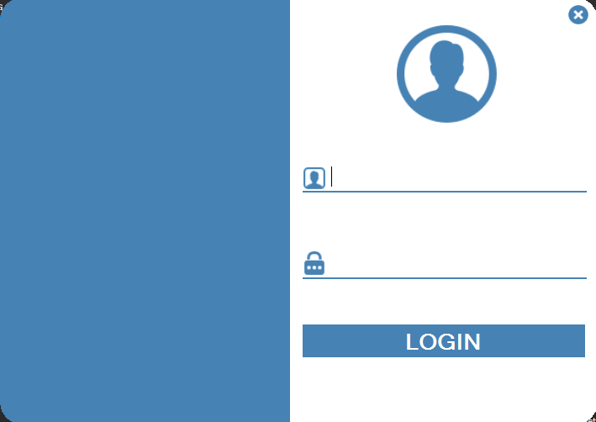

Source: Own drawing

This interface it is the first interface to appear once the system is lunched and it provide the login
interface where users can login into the system. The user must be the admin.
Once the Admin is logged the system will redirect him to the main dashboard, where the Admin will find and enjoy all system functionalities.

Figure 11 Home Dashboard Interface
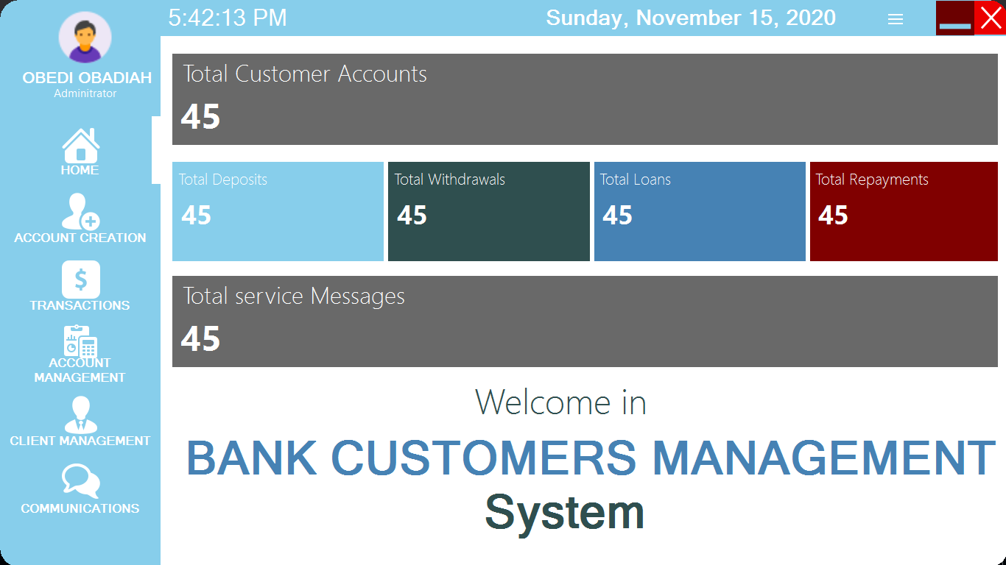

Source: Own drawing

Once the Admin is successfully logged into the system, he or she can see this dashboard that provides different menu buttons such as:
- Home which is the dashboard or the home page of the system ;
- Account Creation for creating new customer account;
- Transactions for making transactions (Deposit, Withdrawal, Loan, Repayment);
- Account Management for managing all stored account in the system;
- Client management for managing all available customers informations stored in the system;
- Communications for the visualization of all service message communications.

In the home interface the Admin will find also:
- The total number of all customer accounts stored in the system;
- The total number of all deposit transactions stored in the system;
- The total number of all Withdrawal transactions stored in the system;
- The total number of all Loan transactions stored in the system;
- The total number of all Repayment transactions stored in the system;
- The total number of all Service message communications stored in the system;

Figure 12 Account Creation for Personal customer details Interface
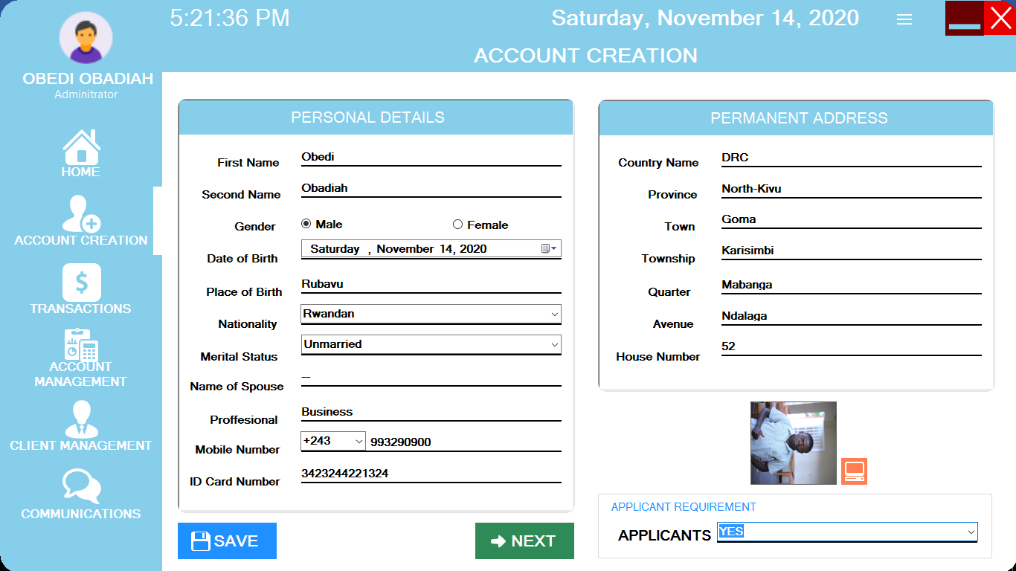

Source: Own drawing

The admin is redirected to the Account Creation for Personal customer details interface by a simple clicking to the “ACCOUNT CREATION” button where the admin can register all personal customer informations.
These are personal customer informations to be register:
First Name, Second Name, Gender, Date of Birth, Place of Birth, Nationality, Merital Status, Name of spouse , Profession, Mobile Number Code, Mobile Number, IDCard Number, Country Name, Province, Town, Township, Quarter, Avenue, House Number, Picture.
Once all informations are filled then the Admin will press “SAVE” button to register those informations.

Figure 13 Account Creation for Applicant details Interface
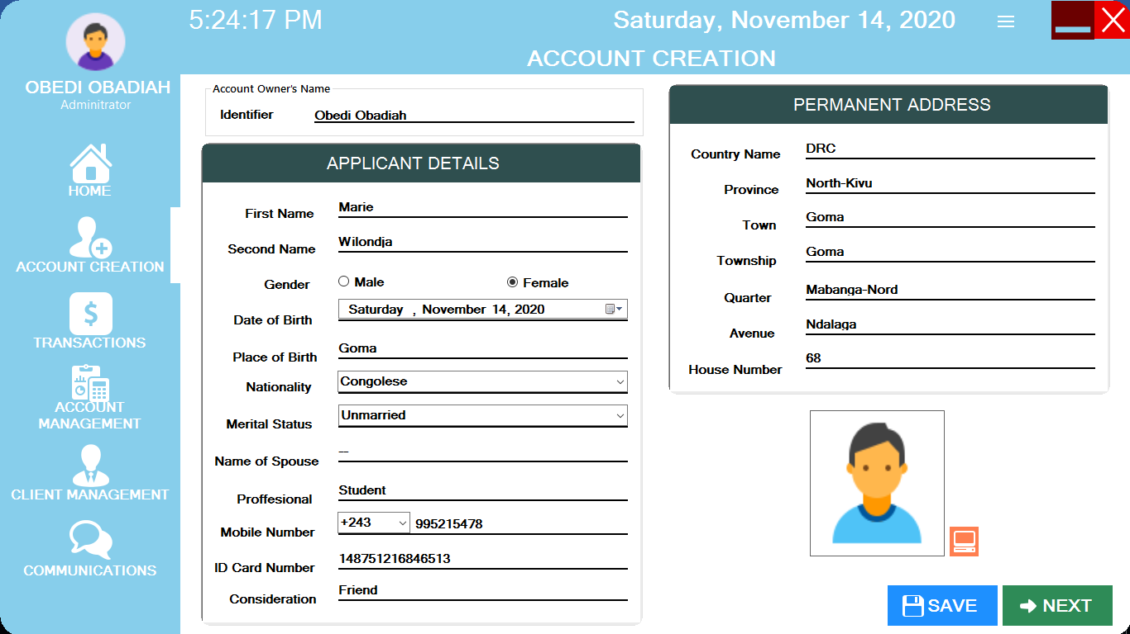

Source: Own drawing

After registering Personal customer informations registered the admin is redirected to the Account Creation for Applicant details interface by a simple clicking to the “NEXT” button where the admin can register all Applicant customer informations.
These are Applicant informations to be register:
Identifier, First Name, Second Name, Gender, Date of Birth, Place of Birth, Nationality, Merital Status, Name of spouse , Profession, Mobile Number Code, Mobile Number, IDCard Number, Consideration, Country Name, Province, Town, Township, Quarter, Avenue, House Number, Picture.
Once all informations are filled then the Admin will press “SAVE” button to register those informations.

Figure 14 Bank Account details Interface
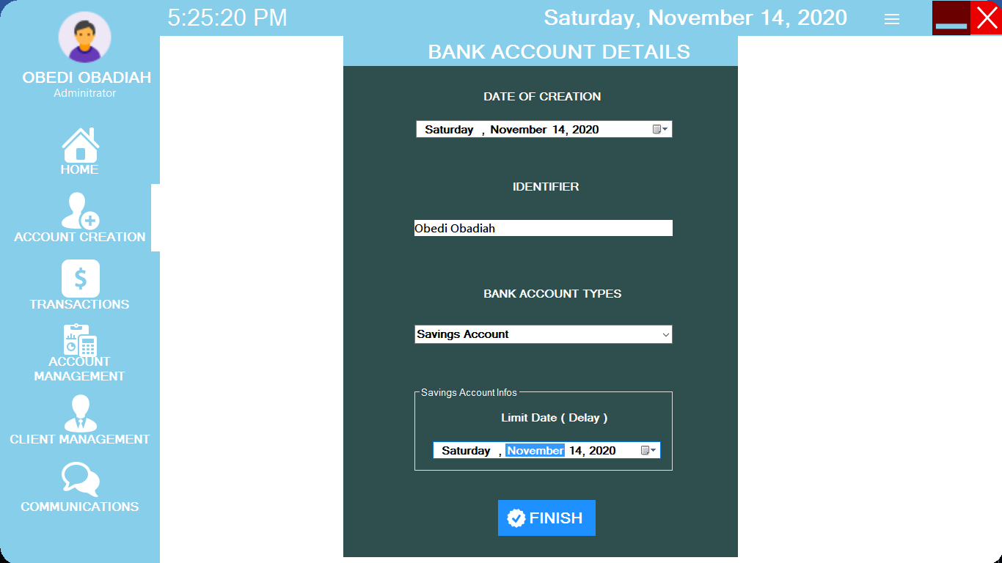

Source: Own drawing

After registering Applicant informations registered the admin is redirected to the Bank Account details interface by a simple clicking to the “NEXT” button where the admin can register all bank account details.
These are Bank account informations to be register are:
- Date of Creation;
- Identifier, which is the name of the account owner;
- Bank account types;
- Limit date(Delay) which appears only when the Bank Account type is the Saving Account;
Once all informations are filled then the Admin will press “FINISH” button to register those informations.

Figure 15 Transaction menu interface
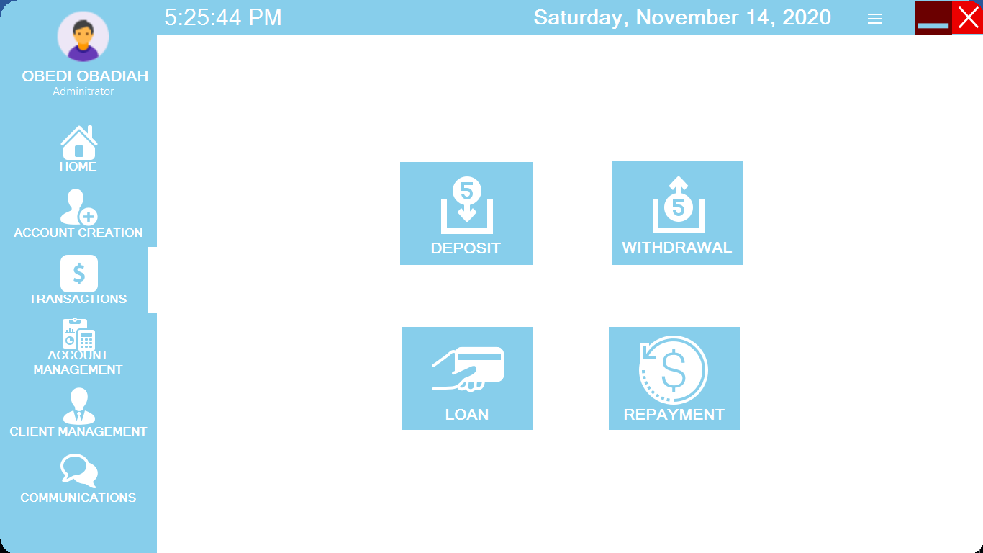

Source: Own drawing

Once the Account creation is finish then the Admin will be redirected to Transaction menu interface by a simple clicking to the “TRANSACTIONS” button where he or she can find the menu of all available transactions in the system.
There are the available transactions in the system:
- Deposit transaction;
- Withdrawal transaction;
- Loan transaction;
- Repayment transaction.
Thereafter the Admin can choose which transaction he or she want to make.
Figure 16 Deposit transaction interface
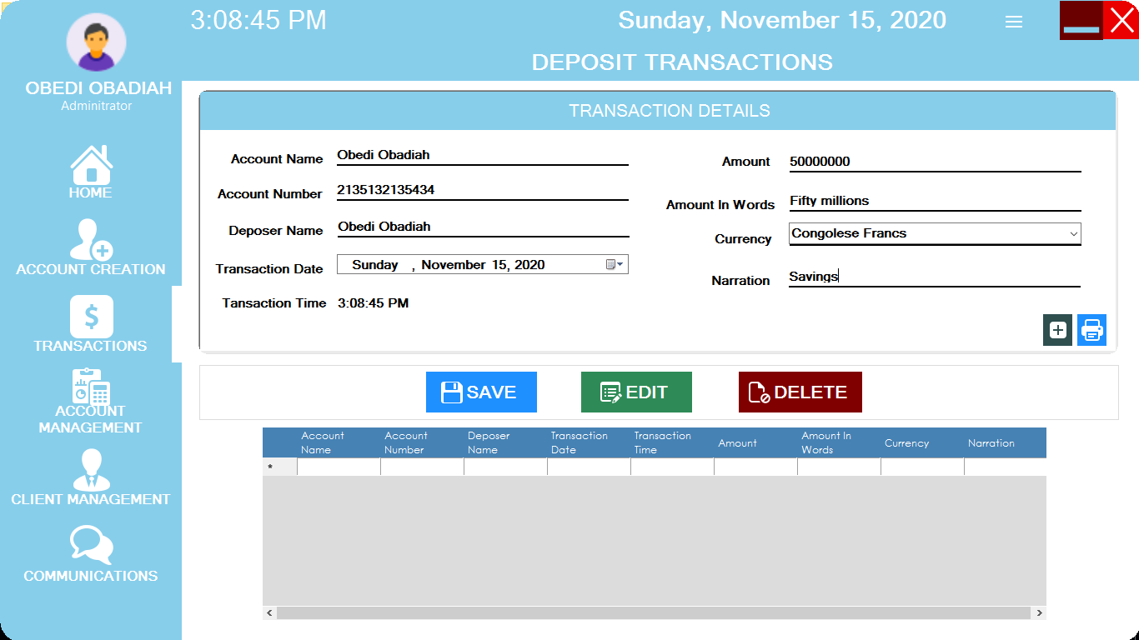

Source: Own drawing

The admin is redirected to the Deposit transaction interface by a simple clicking to the “DEPOSIT” button where the admin can perform the customer transaction and manage Deposit transaction saved informations by editing and deleting; the Admin can also print the Deposit slips.
These are Deposit required information to be saved:
Account Name, Account Number, Deposer Name, Transaction Date, Transaction Time, Amount, Amount in Word, Currency, Narration.
Once all required informations are filled then the Admin will press “SAVE” button to register those informations.
The Admin can press “EDIT” button to edit customer saved informations.
The Admin can press “DELETE” button to delete customer saved informations.

Figure 17 Withdrawal Transaction Interface
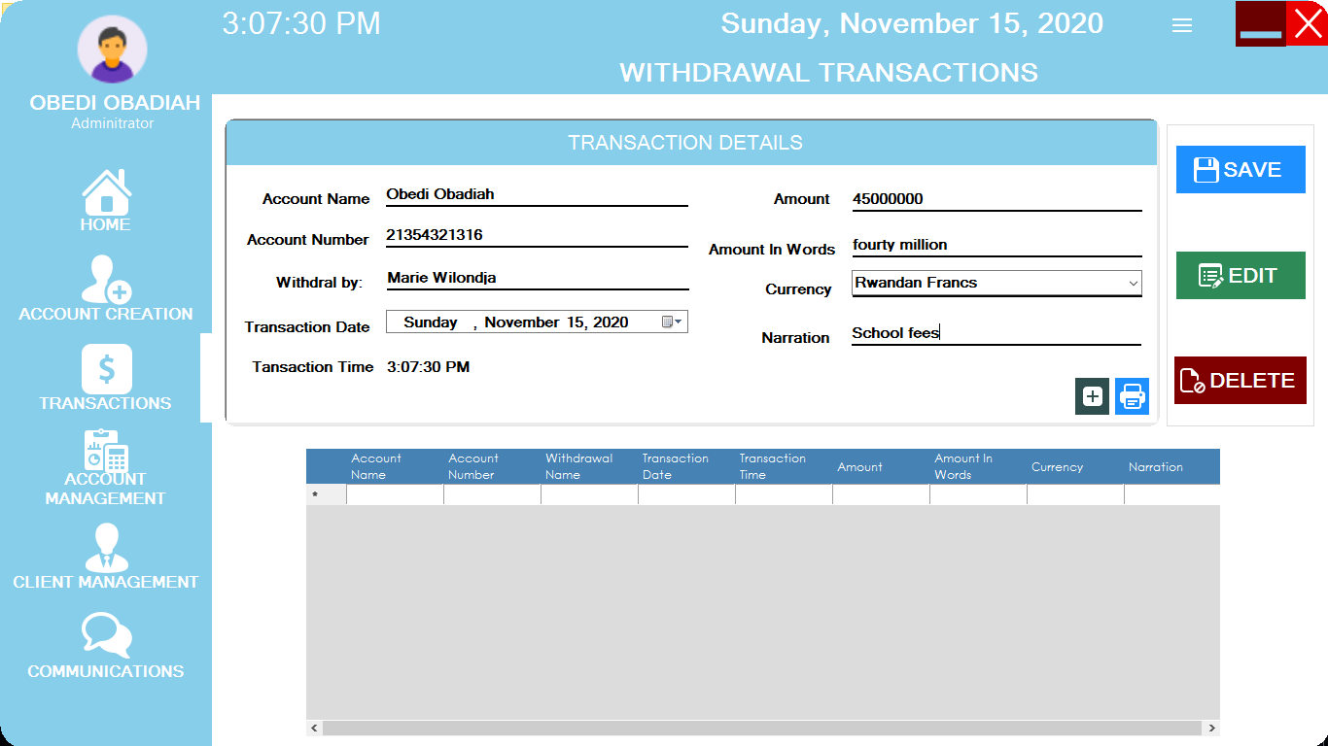

Source: Own drawing

The admin is redirected to the Withdrawal transaction interface by a simple clicking to the “WITHDRAWAL” button on the “Transaction menu interface”, where the admin can perform the customer Withdrawal transaction and manage Withdrawal transaction saved informations by editing and deleting; the Admin can also print the Withdrawal slips.
These are Withdrawal required information to be saved:
Account Name, Account Number, Withdrawal By, Transaction Date, Transaction Time, Amount, Amount in Word, Currency, Narration.
Once all required informations are filled then the Admin will press “SAVE” button to register those informations.
The Admin can press “EDIT” button to edit customer saved informations.
The Admin can press “DELETE” button to delete customer saved informations.

Figure 18 Loan Transaction Interface
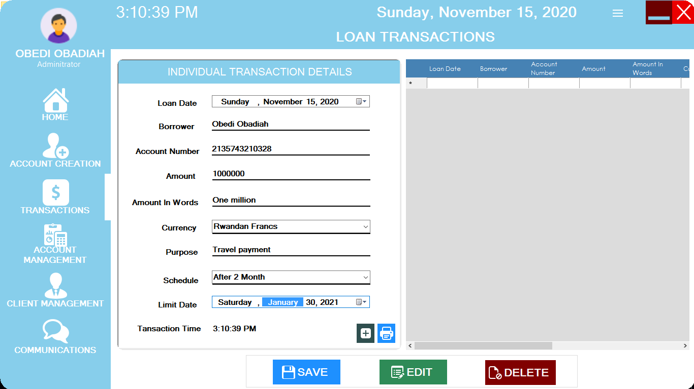

Source: Own drawing

The admin is redirected to the Loan transaction interface by a simple clicking to the “LOAN” button on the “Transaction menu interface”, where the admin can perform the customer Loan transaction and manage Loan transaction saved informations by editing and deleting; the Admin can also print the Loan slips.
These are Loan required information to be saved:
Loan Date, Borrower, Account Number, Amount, Amount in Word, Currency, Purpose, Schedule, Limit Date, Transaction Time.
Once all required informations are filled then the Admin will press “SAVE” button to register those informations.
The Admin can press “EDIT” button to edit customer saved informations.
The Admin can press “DELETE” button to delete customer saved informations.

Figure 19 Repayment Transaction Interface
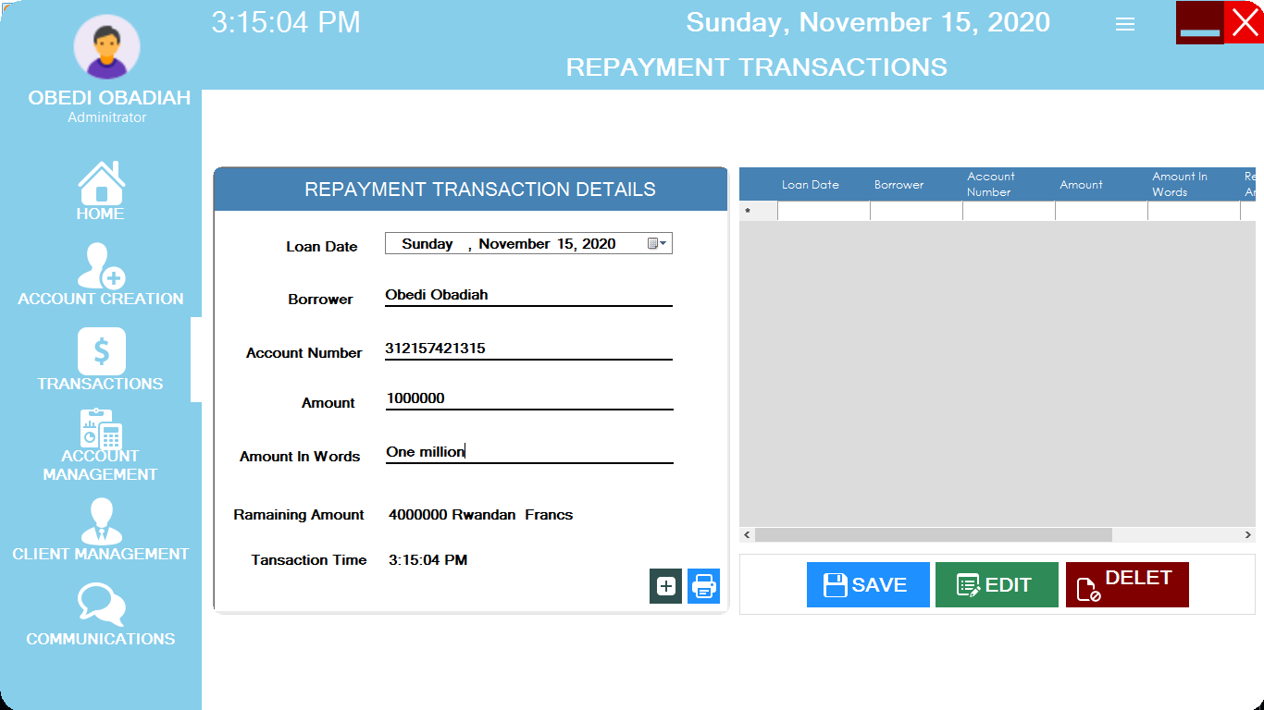
Source: Own drawing

The admin is redirected to the Repayment transaction interface by a simple clicking to the “REPAYMENT” button on the “Transaction menu interface”, where the admin can perform the customer Repayment transaction and manage Repayment transaction saved informations by editing and deleting; the Admin can also print the Repayment slips.
These are Repayment required information to be saved:
- Loan Date, which is the date of the transaction;
- Borrower;
- Account Number;
- Amount;
- Amount in words;
- Remaining Amount, which is the remaining amount from the loan amount.
Once all required informations are filled then the Admin will press “SAVE” button to register those informations.
The Admin can press “EDIT” button to edit customer saved informations.
The Admin can press “DELETE” button to delete customer saved informations.

Figure 20 The Account Management Interface
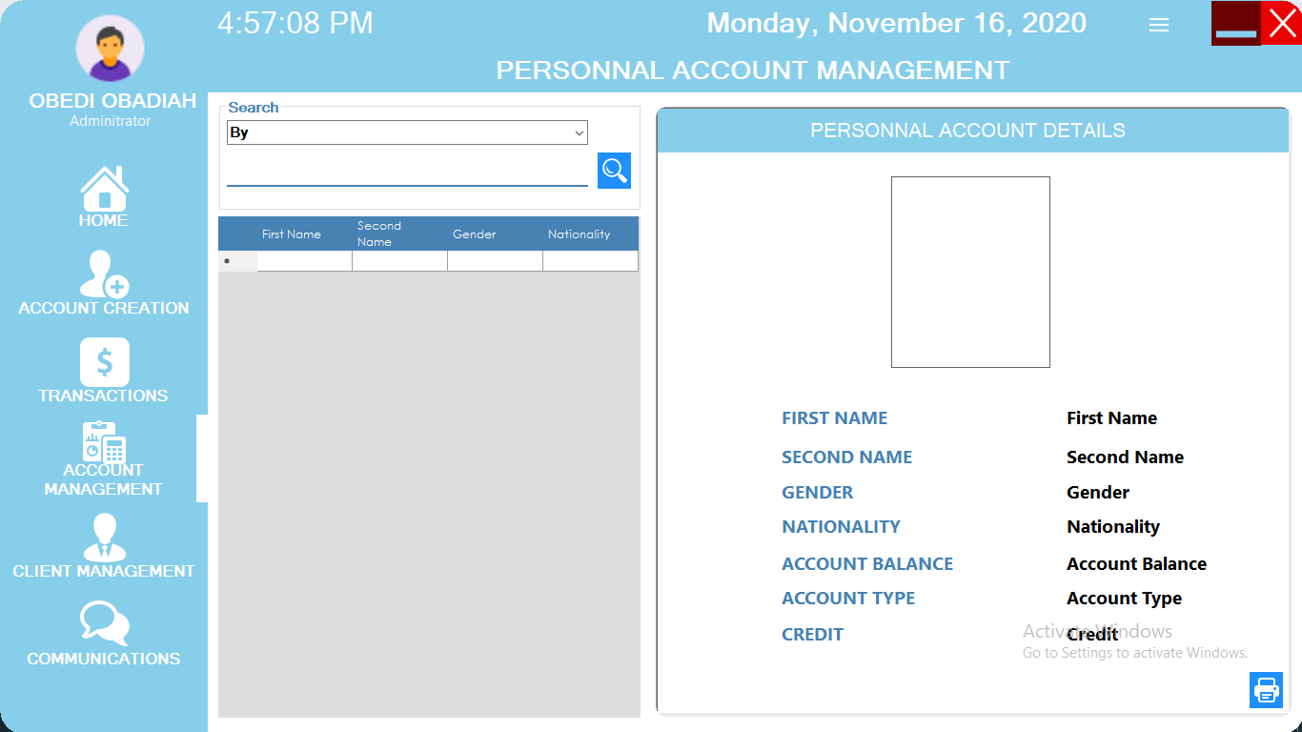

Source: Own drawing

The admin is redirected to the Account Management Interface by a simple clicking to the “ACCOUNT MANAGEMENT” button where the admin can just view customer specified informations such as:
- Fist Name, which is the first name of the customer;
- Second Name, which is the second name of the customer;
- Gender, which is the gender of the customer;
- Nationality, which is nationality of the customer;
- Account Balance, which the customer account balance;
- Account Type, which is the customer account type;
- Credit, which is the customer available loan.

Figure 21 Personal Details Management Interface
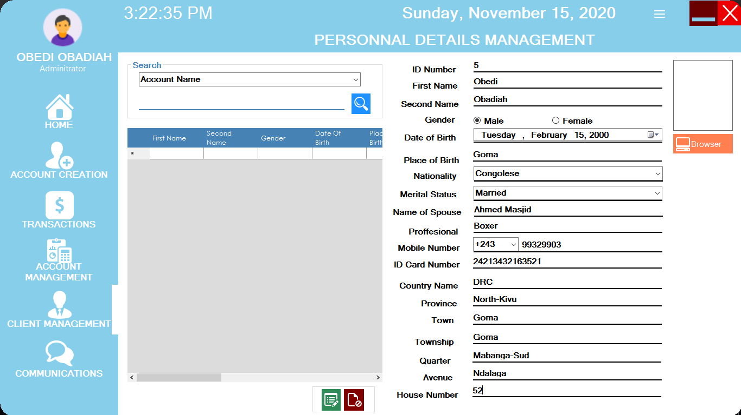

Source: Own drawing

The admin is redirected to the Personal Details Management interface by a simple clicking to the “PERSONAL DETAILS” button on the “Client Management Menu”, where the admin can manage the customer personal informations by editing and deleting.
These are Personal Details information to be managed:
ID Number, First Name, Second Name, Gender, Date of Birth, Place of Birth, Nationality, Merital Status, Name of spouse , Profession, Mobile Number Code, Mobile Number, IDCard Number, Country Name, Province, Town, Township, Quarter, Avenue, House Number, Picture.
Once all required informations are filled then the Admin can press “EDIT” button to edit customer saved informations.
The Admin can press “DELETE” button to customer Personal Details saved informations.

Figure 22 Applicant Details Management Interface
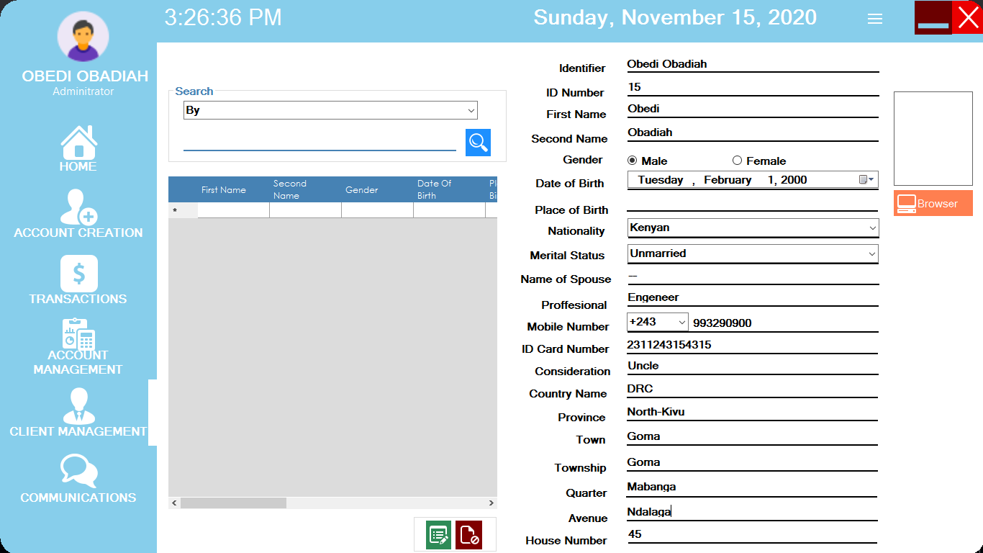

Source: Own drawing

The admin is redirected to the Applicant Details Management interface by a simple clicking to the “APPLICANT DETAILS” button on the “Client Management Menu”, where the admin can manage the customer applicant informations by editing and deleting.
These are Applicant Details information to be managed:
Identifier, ID Number, First Name, Second Name, Gender, Date of Birth, Place of Birth, Nationality, Merital Status, Name of spouse , Profession, Mobile Number Code, Mobile Number, IDCard Number, Consideration, Country Name, Province, Town, Township, Quarter, Avenue, House Number, Picture.
Once all required informations are filled then the Admin can press “EDIT” button to edit customer saved informations.
The Admin can press “DELETE” button customer applicant saved informations.
Figure 23 Bank Account Management Interface
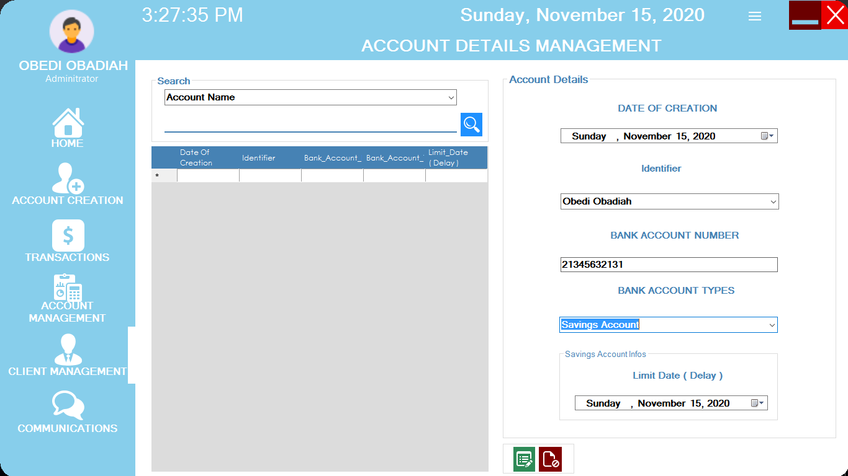

Source: Own drawing

The admin is redirected to the Bank Account Management interface by a simple clicking to the “BANK ACCOUNT DETAILS” button on the “Client Management Menu”, where the admin can manage the customer Bank Account informations by editing and deleting.
These are Bank Account Details information to be managed:
- ID Number;
- Date of Creation;
- Identifier, which is the name of the account owner;
- Bank account types;
- Limit date(Delay) which appears only when the Bank Account type is the Saving Account;
Once all required informations are filled then the Admin can press “EDIT” button to edit Bank Account saved informations.
The Admin can press “DELETE” button to customer Bank Account saved informations.
Figure 24 The Administrator Registration Interface
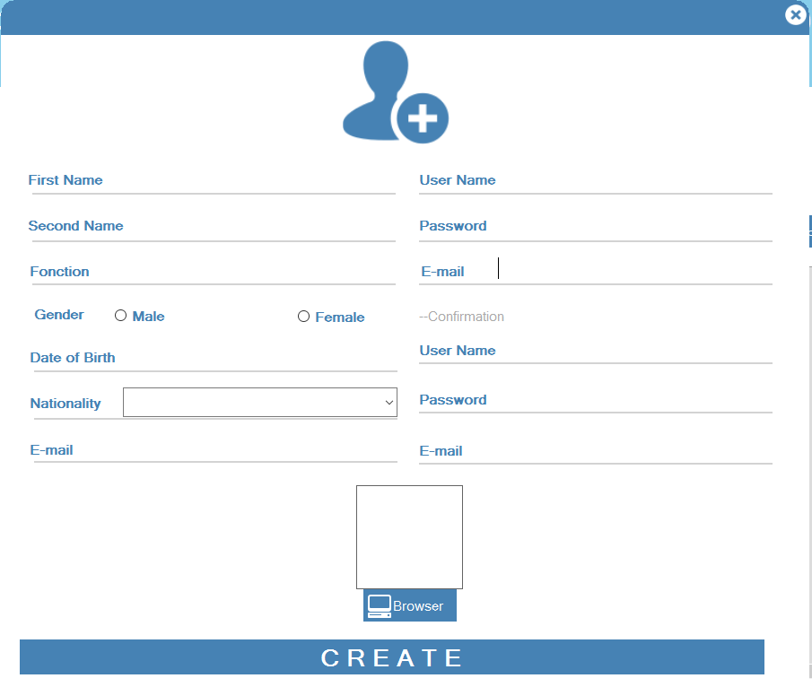

Source: Own drawing

The admin is redirected to the Administrator Registration interface by a simple clicking to the “ADMINSTRATOR PICTURE” button on the “Main Form”, where the admin can register or create another administrator account.
These are the Administrator Registration informations to be register:
- First Name, Second Name, Function, Gender, Date of Birth, Nationality, E-Mail, Username, Password
- E-Mail, Username, Password, E-Mail, these are for the confirmation of the Administrator account.
Once all required informations are filled then the Admin can press “CREATE” button to create another administrator account.
Figure 25 Communication Sender Interface
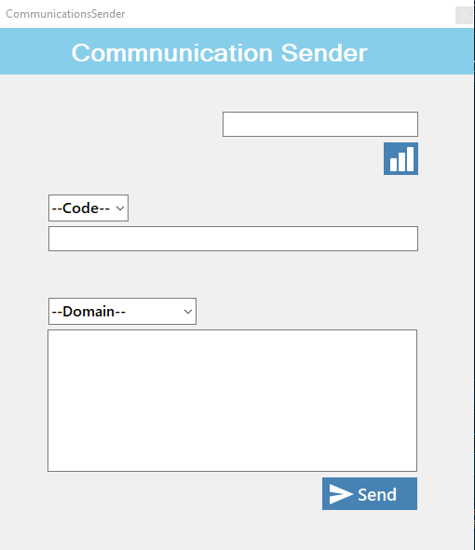

Source: Own drawing

The admin is redirected to the Communication Sender interface by a the end of each basic available services in the system where the admin can send the customers a services feedback message.
These are Communication Sender information to be register:
- Port Number of the connected mode;
- Country Code for the phone number;
- Domain, which is the domain of the services provided;
- Content, which is the massage to be sent;
Once all required informations are filled then the Admin can press “SEND” button to send the message feedback the customers.

Figure 26 Communication viewer Interface
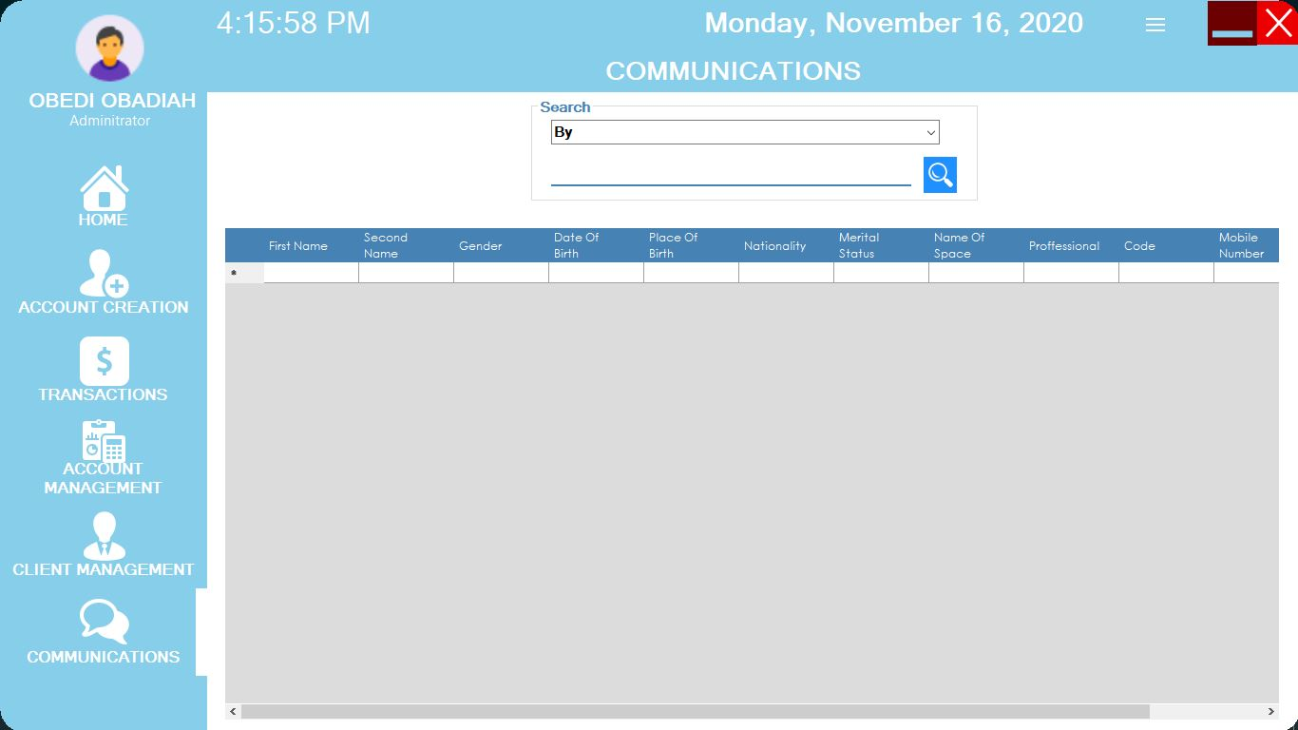

Source: Own drawing

The admin is redirected to the Communication viewer Interface by a simple clicking to the “COMMUNICATIONS” button where the admin can just view all sent services messages feedback available in the system.

CHAPTER 5. CONCLUSION AND RECOMMANDATION

CONCLUSION

Throughout this work it has been developed a full Bank customers management system that will help bank to manage correctly their customers and to provide good services in order to fight against the time consuming, the waste of resources.
So we can now prove those problems are now going to be solved by the best practices used to design and build the computerized Bank customers management system.
After making the analyze of the current system, we found that it was very important to build a system which will be able to solve the problem. Its development was not only a benefit for banks but also for us who developed it because we have sincerely learned so many things in the interaction of bank services and the desktop applications field and it gave us important experience and more additional knowledge about bank services principles.
At the end of this project we are really satisfied with the achievement and with the knowledge we got through the execution of this project.

RECOMMANDATION

In the future we recommend to other researchers interested in this project to implement another version of this project and add other important features by improving and making it more larger that a Bank customers management by adding other services such as:
- The customer money transfer;
- The Loan transactions of a group of people and companies;
- Salary payment of companies employees.
- Human resources management.
We also recommend the banks to use this system as it solves several previous problems of it during the execution of the tasks.

REFERENCES

- Paul Monk. (September 8, 2014). Desktop Application, Retrieve from quora: https://www.quora.com/What-are-desktop-applications
- Nishadha(October 21, 2020). Diagrams, Retrieve from creately.com : https://creately.com/blog/diagrams/er-diagrams-tutorial/
- Shaitanya Singh. DBMS, Retrieve from beginnersbook.com: https://beginnersbook.com/2015/04/e-r-model-in-dbms/
- Chen Peter (March 1976).
- “The Entity Relationship model – Toward a unified view of Data”. Entity Relationship model, Retrieve from Wikipedia.com https://en.m.wikipedia.org/wiki/Entity–relationship_model
- Google.com. Dataflow diagram symbols. Retrieve from google.com https://www.google.com/search?client = Dataflow+diagram+symbols+explanation
- Joel Bangerter (2018). Data Flow Diagram. Retrieve from lucidchart .com https://www.lucidchart.com/blog/data-flow-diagram-tutorial
- Geeksforgeeks (October 28,2020). Levels in Data Flow Diagram. Retrieve from geeksforgeeks .com: https://www.geeksforgeeks.org/levels-in-data-flow-diagrams-dfd/
- visual-paradigm.com (2017). What-Is-Entity-Relationship-Diagram. Retrieve from visual-paradigm.com : https://www.visual-paradigm.com/guide/data-modeling/what-is-entity-relationship-diagram/
- visual-paradigm (2017). What-Is-Data-Flow-Diagram . Retrieve from visual-paradigm.com : https://www.visual-paradigm.com/guide/data-flow-diagram/what-is-data-flow-diagram/
- Bruza P.D, Van Der Weid, Th. P (November 01, 1990). Data Flow Diagram. Retrieve from Wikipedia.com: https://en.m.wikipedia.org/wiki/Data-flow_diagram
- EARS: “The Easy Approach to Requirement Syntax.” International Academy, Research, and Industry Association, (2018). Functional and Non-Functional Requirement. Retrieve from qracorp.com: https://qracorp.com/functional-vs-non-functional-requirements/
- Google. Database Cardinality. Retrieve from Google.com: comhttps://www.google.com/search?client=Database+Cardinality+Definition&oq=Databse+Cardinality+Definition&aqs=heirloom-srp.
- Martin Gibbs(2016) . What Is An Entity In A Database. Retrieve from study .com: https://study.com/academy/lesson/what-is-an-entity-in-a-database.html
- E. F. Codd(1970) “A Relational Model of Data for Large Shared Data Banks” Communication of the ACM https://en.m.wikipedia.org/wiki/Relational_database
- W3school. SQL ForeignKey. Retrieve from W3school.com https://www.w3schools.com/sql/sql_foreignkey.asp
- Google. Database attributes. Retrieve from google.com: https://www.google.com/search?client =Database+attributes+Definition&oq=Database+attributes+Definition
- Bureau of Labor Statistics “Database Administrators” (November 04, 2015). Database Administrators. Retrievem from Wikipedia.com :https://en.m.wikipedia.org/wiki/Database_administrator
- Thakur Dinesh (February 03, 2018). What is a Database Server. Retrieve from Wikipedia.com: ”https://en.m.wikipedia.org/wiki/Database_server
- Techterms (August 25, 2012). Record. Retrieve from Techterms .com https://techterms.com/definition/record
- teachcomputerscience (2020). Database queries. Retrieve from teachcomputerscience .com: https://teachcomputerscience.com/database-queries/
- IBM Cloud Education (August27,2019). Database Security. Retrieve from Wikipedia .com :https://en.m.wikipedia.org/wiki/Table_(database)https://www.ibm.com/cloud/learn/database-security
- Graves Steve “COTS Database For Embedded System” Archived (November 11, 2014). Database. Retrieve from Wikipedia.com: https://en.m.wikipedia.org/wiki/Database
- Cambridge University Press(November 11, 2020). Data. Retrieve from dictionary.cambridge.org : https://dictionary.cambridge.org/dictionary/english/data
- Google. Data definition. retrieve from google.com: https://www.google.com/search?client =Data+Definition
- Dictionary.Information. Retrieve from dictionary.com: https://www.dictionary.com/browse/information
- techterms (June 4, 2014). C_Sharp. Retrieve from techterms.com: https://techterms.com/definition/c_sharp
- Indeed, (February 4, 2020). User Interface. Retrieve from indeed.com : https://www.indeed.com/career-advice/career-development/user-interface
- Cohen Philip R.(1992) “The role of natural language in a multimodal interface” p.143-149.User Interface. Retrieve from Wikipedia.com: https://en.m.wikipedia.org/wiki/User_interface
- (April 30, 2020)https://www.techopedia.com/definition/26272/c-sharp
- omnisci . DBMS. Retrieve from omnisci.com: https://www.omnisci.com/technical-glossary/dbms
- merriam-webster , (1646). Data. Retrieve from merriam-webster.com: https://www.merriam-webster.com/dictionary/data
- The new social Operating System (2012). Software. Retrieve from merriam-webster.com: https://www.merriam-webster.com/dihttps://en.m.wikipedia.org/wiki/Software
- Luciano Floridi(2010).Information. Retrieve from Wikipedia.com: https://en.m.wikipedia.org/wiki/Information
- https://encyclopedia2.thefreedictionary.com/desktop+application

